ANNEXES

APPLICATION SUBMISSION FORM & CHECKLIST OF DOCUMENTS TO BE SUBMITTED
“2020 EDA Defence Innovation Prize”
Innovative Solutions/Technologies for the Countering of Swarms of UAVs, Specifically on the Protection of Static and Dynamic Land Facilities and Platforms
20.RTI.PRZ.080
- SUBMITTED by (i.e. the identity of the Applicant)
 | Name(s) of legal entity or entities submitting this application. | Nationality
Lead participant
Participant 2
Etc …
- CONTACT PERSON for this application (to act as focal point for all communication which may take place between EDA and the Applicant)
Name and position
Organisation
Address
Telephone
e-mail

Signed on behalf of the Applicant:

Name
Signature
Date

Checklist of documents to be submitted
The purpose of the table below is to facilitate the preparation of the application by providing an overview of the documents that shall be included (marked by ) depending on the role of each participant in the application (lead participant in joint application, participant in joint application, single participant).
Description | Lead participant | All participants in joint application | Single Participant
Application submission form
Legal Entity Form

Supporting documents for the Legal Entity File Form

Financial Identification form (either signed & stamped by the bank or accompanied by a recent bank statement)

Exclusion Criteria form
Proposal

EXCLUSION CRITERIA FORM (CONTEST NO 20.RTI.PRZ.080)
Declaration on honour on
exclusion criteria

The undersigned [insert name of the signatory of this form], representing:
(only for natural persons) himself or herself | (only for legal persons) the following legal person:
ID or passport number:  (‘the person’) | Full official name:  Official legal form:  Statutory registration number:  Full official address:  VAT registration number:  (‘the person’)

I – Situation of exclusion concerning the person
- declares that the above-mentioned person is in one of the following situations: | YES | NO
- it is bankrupt, subject to insolvency or winding up procedures, its assets are being administered by a liquidator or by a court, it is in an arrangement with creditors, its business activities are suspended or it is in any analogous situation arising from a similar procedure provided for under national legislation or regulations;
- it has been established by a final judgement or a final administrative decision that the person is in breach of its obligations relating to the payment of taxes or social security contributions in accordance with the law of the country in which it is established, with those of the country in which the contracting authority is located or those of the country of the performance of the contract;
- it has been established by a final judgement or a final administrative decision that the person is guilty of grave professional misconduct by having violated applicable laws or regulations or ethical standards of the profession to which the person belongs, or by having engaged in any wrongful conduct which has an impact on its professional credibity where such conduct denotes wrongful intent or gross negligence, including, in particular, any of the following:
(i) fraudulently or negligently misrepresenting information required for the verification of the absence of grounds for exclusion or the fulfilment of selection criteria or in the performance of a contract;
(ii) entering into agreement with other persons with the aim of distorting competition;
(iii) violating intellectual property rights;
(iv) attempting to influence the decision-making process of the contracting authority during the award procedure;

(v) attempting to obtain confidential information that may confer upon it undue advantages in the award procedure;
- it has been established by a final judgement that the person is guilty of the following:
(i) fraud, within the meaning of Article 1 of the Convention on the protection of the European Communities' financial interests, drawn up by the Council Act of 26 July 1995;
(ii) corruption, as defined in Article 3 of the Convention on the fight against corruption involving officials of the European Communities or officials of EU Member States, drawn up by the Council Act of 26 May 1997, and in Article 2(1) of Council Framework Decision 2003/568/JHA, as well as corruption as defined in the legal provisions of the country where the contracting authority is located, the country in which the person is established or the country of the performance of the contract;
(iii) participation in a criminal organisation, as defined in Article 2 of Council Framework Decision 2008/841/JHA;
(iv) money laundering or terrorist financing, as defined in Article 1 of Directive 2005/60/EC of the European Parliament and of the Council;
(v) terrorist-related offences or offences linked to terrorist activities, as defined in Articles 1 and 3 of Council Framework Decision 2002/475/JHA, respectively, or inciting, aiding, abetting or attempting to commit such offences, as referred to in Article 4 of that Decision;
(vi) child labour or other forms of trafficking in human beings as defined in Article 2 of Directive 2011/36/EU of the European Parliament and of the Council;
- the person has shown significant deficiencies in complying with the main obligations in the performance of a contract financed by the Union’s budget, which has led to its early termination or to the application of liquidated damages or other contractual penalties, or which has been discovered following checks, audits or investigations by an Authorising Officer, OLAF or the Court of Auditors;
- it has been established by a final judgment or final administrative decision that the person has committed an irregularity within the meaning of Article 1(2) of Council Regulation (EC, Euratom) No 2988/95;

- for the situations of grave professional misconduct, fraud, corruption, other criminal offences, significant deficiencies in the performance of the contract or irregularity, the applicant is subject to:
- facts established in the context of audits or investigations carried out by the Court of Auditors, OLAF or internal audit, or any other check, audit or control performed under the responsibility of an authorising officer of an EU institution, of a European office or of an EU agency or body;
- non-final administrative decisions which may include disciplinary measures taken by the competent supervisory body responsible for the verification of the application of standards of professional ethics;
- decisions of the ECB, the EIB, the European Investment Fund or international organisations;
- decisions of the Commission relating to the infringement of the Union's competition rules or of a national competent authority relating to the infringement of Union or national competition law; or
- decisions of exclusion by an authorising officer of an EU institution, of a European office or of an EU agency or body.

II – Situations of exclusion concerning natural persons with power of representation, decision-making or control over the legal person
Not applicable to natural persons, Member States and local authorities
- declares that a natural person who is a member of the administrative, management or supervisory body of the above-mentioned legal person, or who has powers of representation, decision or control with regard to the above-mentioned legal person (this covers company directors, members of management or supervisory bodies, and cases where one natural person holds a majority of shares) is in one of the following situations: | YES | NO | N/A
Situation (c) above (grave professional misconduct)
Situation (d) above (fraud, corruption or other criminal offence)
Situation (e) above (significant deficiencies in performance of a contract)
Situation (f) above (irregularity)

III – Situations of exclusion concerning natural or legal persons assuming unlimited liability for the debts of the legal person
- declares that a natural or legal person that assumes unlimited liability for the debts of the above-mentioned legal person is in one of the following situations: | YES | NO | N/A

Situation (a) above (bankruptcy)
Situation (b) above (breach in payment of taxes or social security contributions)

IV – Grounds for rejection from this procedure
- declares that the above-mentioned person: | YES | NO
- has distorted competition by being previously involved in the preparation of procurement documents for this procurement procedure.

V – Remedial measures
If the person declares one of the situations of exclusion listed above, it must indicate measures it has taken to remedy the exclusion situation, thus demonstrating its reliability. This may include e.g. technical, organisational and personnel measures to prevent further occurrence, compensation of damage or payment of fines. The relevant documentary evidence which illustrates the remedial measures taken must be provided in annex to this declaration. This does not apply for situations referred in point (d) of this declaration.

VII – Evidence for selection
The signatory declares that the above-mentioned person is able to provide the necessary supporting documents listed in the relevant sections of the rules of contest and which are not available electronically upon request and without delay.
The above-mentioned person may be subject to rejection from this procedure and to administrative sanctions (exclusion or financial penalty) if any of the declarations or information provided as a condition for participating in this procedure prove to be false.

Full name Date Signature

REIMBURSEMENT OF EXPENSES (WINNING APPLICATION)
In line with section 1.3 of the Rules of Contest “EDA will cover the travel expenses and accommodation, for the winner (up to two representatives) to attend the award ceremony for an amount of up to 1,000€ per representative”. The following conditions will apply:

- The contracting authority reimburses travel and subsistence expenses on the basis of the shortest itinerary and the minimum number of nights necessary for overnight stay at the destination.
- The contracting authority reimburses travel expenses as follows:
(a) travel by air: up to the maximum cost of an economy class ticket at the time of the reservation;
(b) travel by boat or rail: up to the maximum cost of a first-class ticket;
(c) travel by car: at the rate of one first class rail ticket for the same journey and on the same day;

In addition, the contracting authority reimburses travel outside Union territory if it has given its prior written approval for the expenses.

- The contracting authority reimburses subsistence expenses on the basis of a daily subsistence allowance as follows:

- for journeys of less than 200 km for a return trip, no subsistence allowance is payable;
- the daily subsistence allowance is payable only on receipt of supporting documents proving that the person concerned was present at the destination;
(c) the daily subsistence allowance takes the form of a flat rate payment to cover all subsistence expenses, including meals, local transport including transport to and from the airport or station, insurance and sundries;
(d) the daily subsistence allowance is reimbursed at the flat rates specified in table 1;
(e) accommodation is reimbursed on receipt of supporting documents proving the necessary overnight stay at the destination, up to the flat rate ceilings specified in table 1.

Table 1

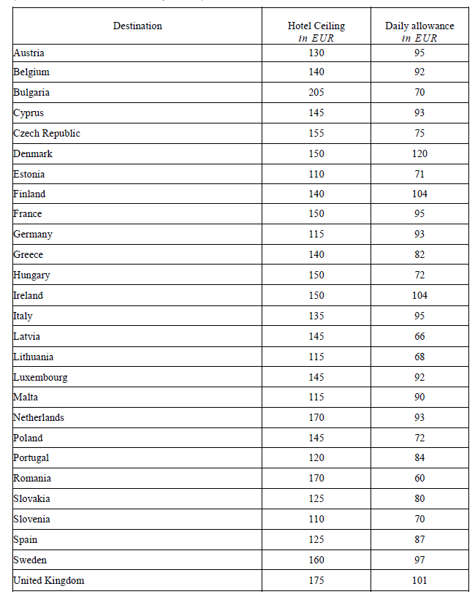

Country in which the legal entity is registered
If this application is being submitted by an individual legal entity, the name of the legal entity should be entered as “Lead participant” (and all other lines should be deleted)

