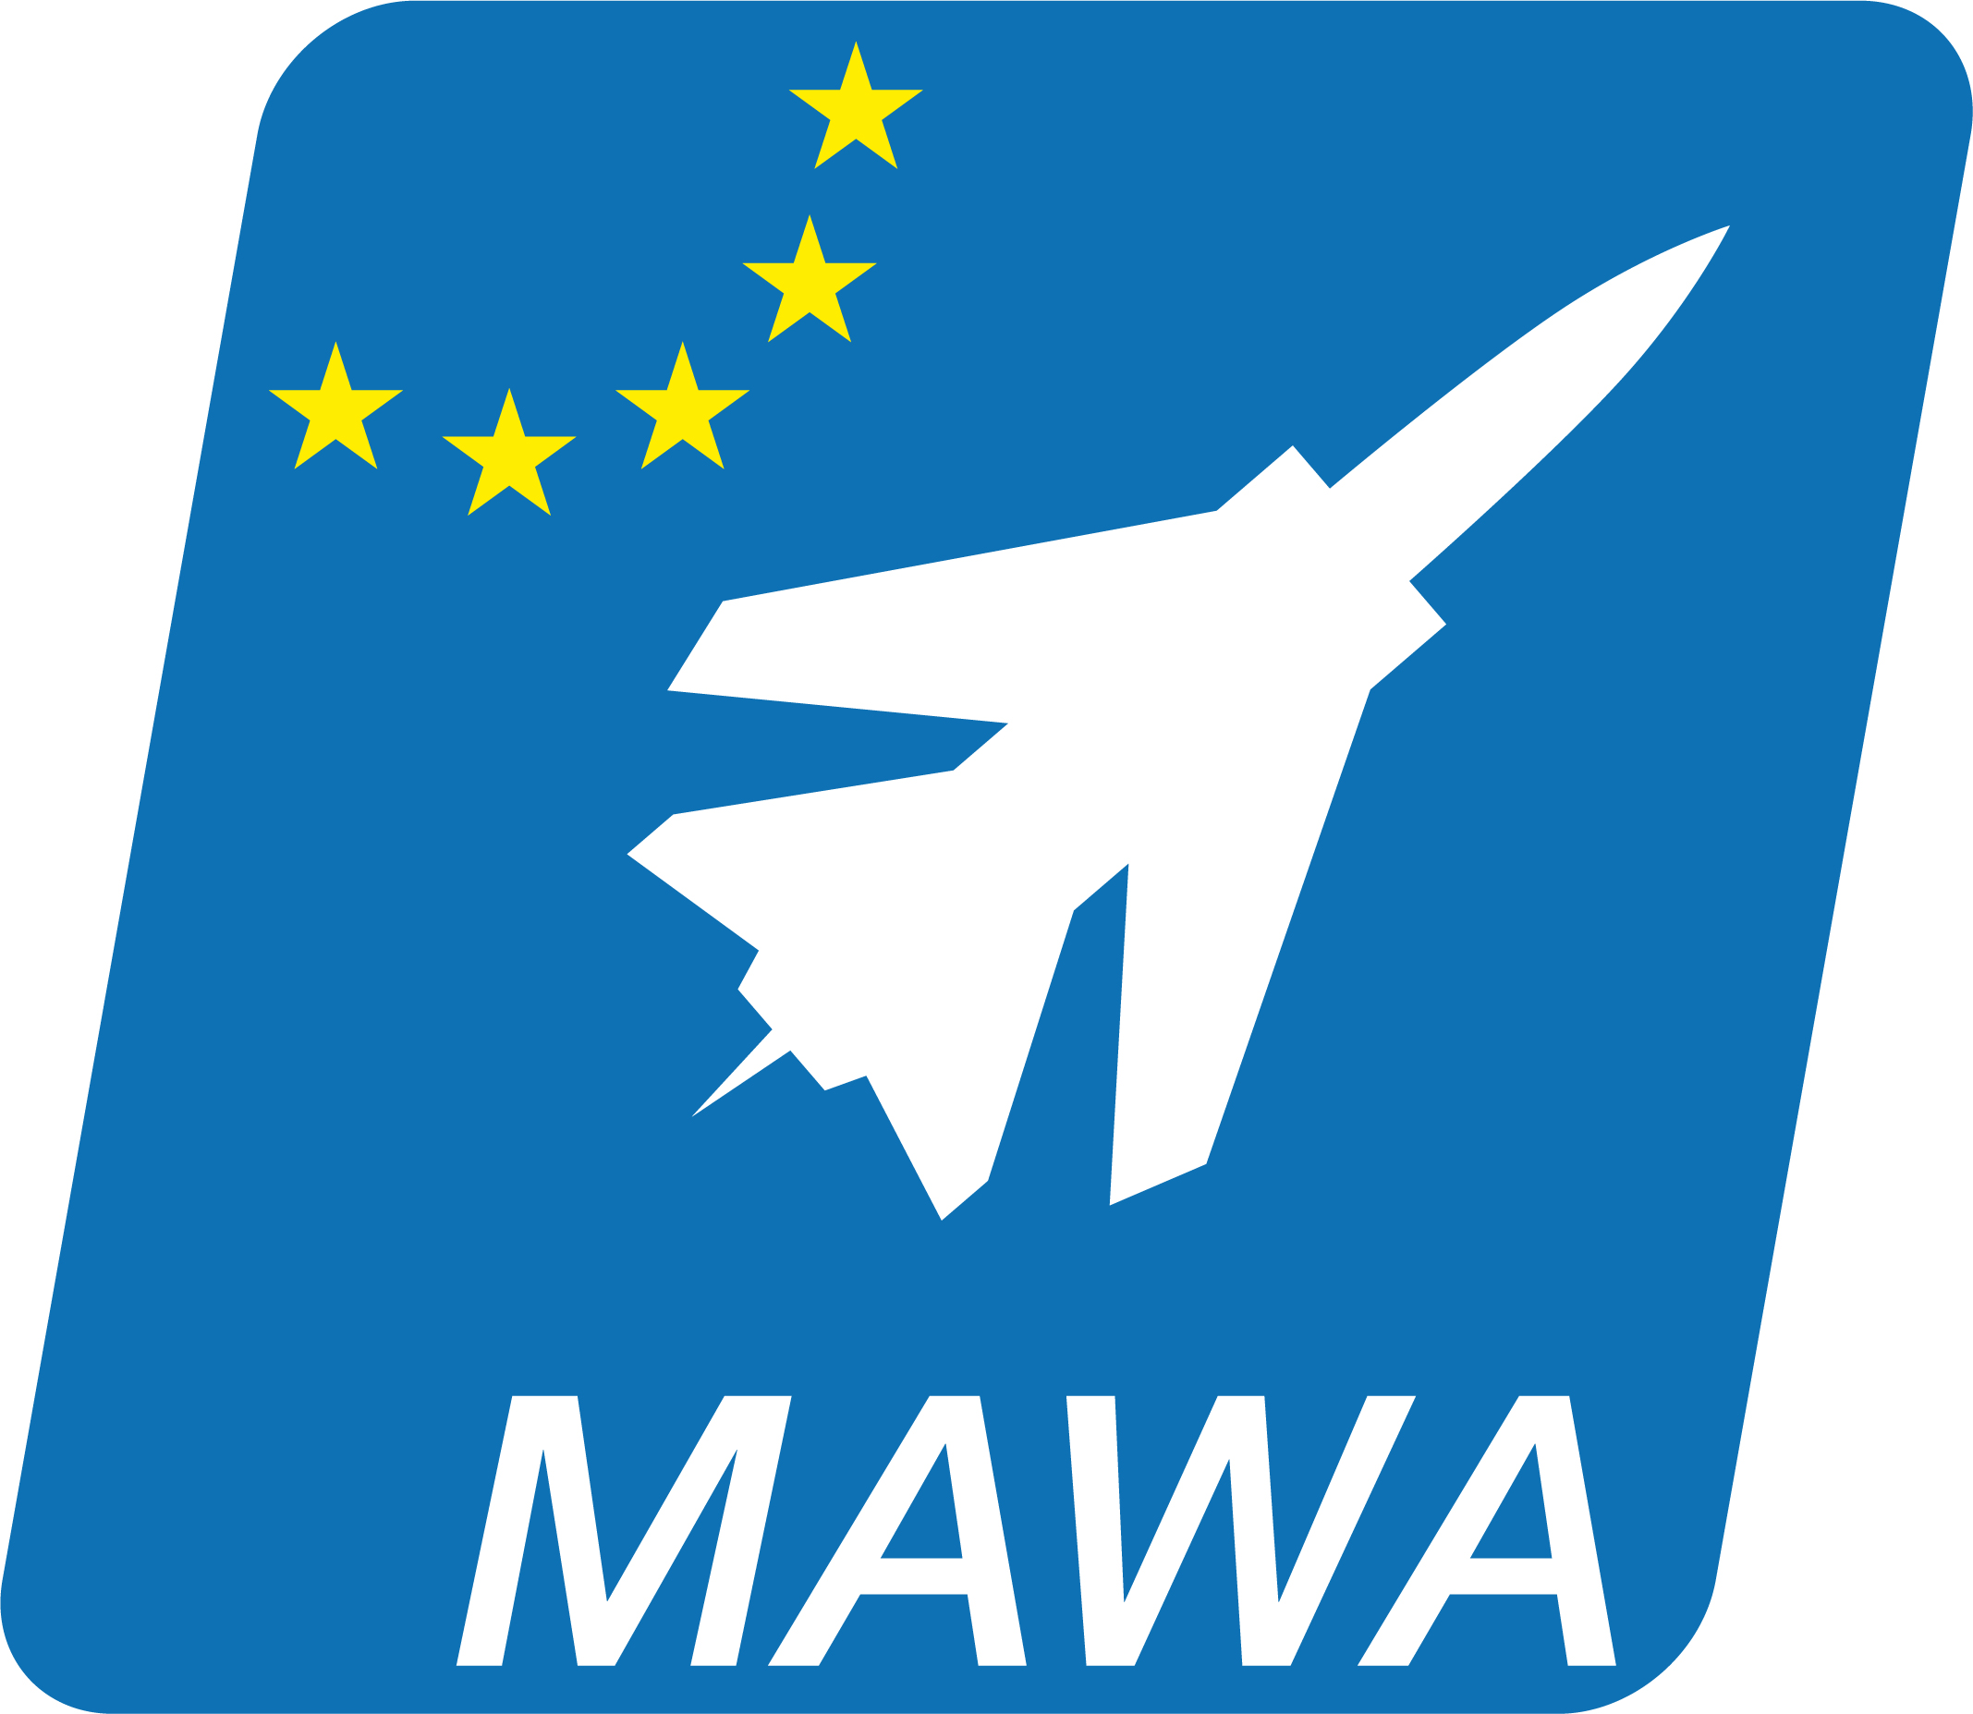
MILITARY AIRWORTHINESS CONFERENCE 2014
Civil aviation within Europe benefits from greater alignment and harmonisation between European member states under the auspices of the European Aviation Safety Agency (EASA). Within civil aviation, EASA regulations are binding documents that must be followed by European civil aviation organisations and individuals, and there is no scope for deviation. However, for national sovereignty issues on defence and security matters, EASA does not have authority. Military aircraft are exclusively subject to national legislation. Therefore until recently, the European military aviation domain has not been able to realize the benefits of greater harmonisation due to the fragmentation of national military regulations between Member States. It is for this reason that in November 2008 the EDA ministerial Steering Board entrusted the EDA with the establishment of a Military Airworthiness Authorities (MAWA) Forum for achieving the harmonisation of military airworthiness regulation and certification processes across Europe. This was a strategic decision that offers many benefits, including enhancing Military aviation safety, improving Military-military and civil-military cooperation, reducing the time and cost for new aircraft development and optimising interoperability during joint air operations. Harmonised national airworthiness regulations are also a key enabler to unlock the benefits for all aviation related ‘pooling and sharing’ initiatives. From the beginning, the MAWA Forum has ensured that industry, through the ASD, has been fully engaged in their activities, and other stakeholders include EASA and the European Air Transport Command.
Harmonisation is being achieved by the publication of European Military Airworthiness Requirements (EMARs). The aim of the EMARs is to provide a set of harmonised requirements that can be implemented into each nation’s own regulatory documentation. Ultimately, the goal is that the EMARs become the uniform ‘standard’ for European military airworthiness, thus avoiding national regulatory differences. The development of the EMARs is a fully inclusive activity. ‘Task Forces’ made up of Subject Matter Experts provided by participating Member States carry out the initial drafting work, and these drafts are then consulted amongst all the participating Member States for comment, amendment and, ultimately, endorsement by the MAWA Forum. This approach has delivered considerable progress – a ‘Basic Framework Document’ that establishes the essential airworthiness principles has been agreed and signed by the Member States, 3 EMARs have already been approved by the MAWA Forum and published on the EDA website with others being developed and further essential supporting documentation also being finalised. The MAWA Forum intends to have the full suite of documentation available by the end of 2015. The adoption of the EMARs into each nation’s regulations will enable the ‘mutual recognition’ of certificates and approvals issued by any of the Military Airworthiness Authorities amongst participating Member States, significantly reducing the certification and approval activities required to introduce new platforms into service as well as reduce In-service Support costs for existing platforms. Most importantly, co-operation amongst the participating Member States will also achieve a uniformly high level of safety. Several Recognition agreements between nations are already in place, using the EMARs as the harmonised baseline.
The MAWA Forum not only oversees the development of the EMARs but also supports and promotes military airworthiness in other ways. A number of very successful workshops have been arranged to resolve specific topics of concern to nations, whilst the annual MAWA Military Airworthiness Conference brings together experts in their field from across the world to discuss, debate and exchange opinions on the latest developments in this developing domain.

