

EMAR Forms Document

Edition Number | 1.2
Edition Date | 4 October 2016
Status | Approved


MILITARY AIRWORTHINESS AUTHORITIES FORUM

DOCUMENT CONTROL

DOCUMENT APPROVAL

The following table identifies the persons who have approved this document

Edition No: |  | MAWA Forum/TF | Authorised by | DATE
1.2 | Prepared by | EDA Airworthiness Office | Henk Corporaal  MAWA Forum Chairman | 14 Sep 2016
1.2 | Approval by | MAWA Forum  F28 | Henk Corporaal  MAWA Forum Chairman | 4 October 2016

DOCUMENT CHANGE RECORD

Edition  Number | Edition  Date | Status | Reason for change  (detailed) | Sections or pages affected
1.0 | 23 Sep 2014 | Approved | Initial Issue | All
1.1 | 12 Oct 2015 | Approved | Inclusion of EMAR M and EMAR 21 Forms | EMAR Forms 14, 15, 20a, 20b, 24, 25, 50, 51, 52, 53, 55, 60, 65
1.2 | 4 Oct 2016 | Approved | Update of EMAR Forms associated with EMAR 21 Ed 1.2 and EMAR 145 Ed 1.2 | EMAR Forms 1, 2, 3, 6, 21

EDITION

Edition will have the following template: Edition X.Y
The value of X will change after a major modification of the document
The value of Y will change after a minor modification of the document

NOTE:

This EMAR Forms document has been assembled for use by organisations and personnel engaged in the production, maintenance and support of military aircraft and airborne equipment to provide a single, consolidated reference-source of all the approved EMAR Forms.

The format and content of each EMAR Form is clearly presented, together with the procedure for its completion and any associated AMC/GM if used. Each EMAR Form has a MAWA Task Force sponsor(s) who is/are responsible for ensuring the Form is maintained at the correct amendment standard. (The date of approval of the EMAR from which the Form was extracted is annotated at the bottom of each Form, enabling users to easily confirm that they are using the latest version.)

If possible language confusion could arise from the use of abbreviated names of months, then the following format shall be used for dates: dd/mm/yyyy where dd = 2 digit day, mm = 2 digit month, yyyy = 4 digit year.

EDA are responsible for publishing this EMAR Forms document based upon input from the respective MAWA Task Force sponsor(s). It shall be available in both ‘.pdf’ and ‘MS word’ versions for ease of reference and use.

TABLE OF CONTENTS

EMAR Form 1 - Authorised Release Certificate 6
AMC to EMAR Form 1 - Authorised Release Certificate 16
GM to EMAR Form 1 - Authorised Release Certificate 19
EMAR Form 2 – Application for EMAR 145 and/or EMAR M Subpart G Approval 21
AMC to EMAR Form 2 - Application for EMAR 145 and/or EMAR M Subpart G Approval 22
EMAR Form 3 – Maintenance Organisation Approval Certificate 23
EMAR Form 4 – NMAA Acceptance of Nominated Management Personnel 25
EMAR Form 6 – EMAR 145 Approval Recommendation Report 26
EMAR Form 11 – Maintenance Training Organisation Approval 33
AMC to EMAR Form 11 - Maintenance Training Organisation Approval 36
EMAR Form 12 – Application for EMAR 147 Initial/Change of Approval 37
EMAR Form 14 - Continuing Airworthiness Management Organisation Approval 38
AMC to EMAR Form 14 - Continuing Airworthiness Management Organisation Approval 40
EMAR Form 15a - Military Airworthiness Review Certificate (NMAA) 41
EMAR Form 15b - Military Airworthiness Review Certificate (CAMO) 42
EMAR Form 18a – Flight Conditions for a Military Permit to Fly 43
EMAR Form 18b – Flight Conditions for a Military Permit to Fly 44
EMAR Form 19 – Military Aircraft Maintenance Licence Application Form 45
EMAR Form 20a – Military Permit To Fly (Authority) 48
EMAR Form 20b – Military Permit To Fly (Approved Organisation) 49
EMAR Form 21 – Application for a Military Permit to Fly 50
EMAR Form 22 - EMAR 147 Approval Recommendation Report 51
EMAR Form 24 – Military Restricted Certificate of Airworthiness 57
EMAR Form 25 – Military Certificate of Airworthiness 58
EMAR Form 26 - Military Aircraft Maintenance Licence (MAML) 59
EMAR Form 50 - Application for EMAR 21 Production Organisation Approval 63
EMAR Form 51 - Application for significant changes or variation of scope and terms of EMAR 21 POA 65
EMAR Form 52 – Military Aircraft Statement of Conformity 67
Instructions for the use of the Aircraft Statement of Conformity EMAR Form 52 68
EMAR Form 53 – Military Certificate of Release To Service 72
EMAR Form 55 – Military Production Organisation Approval Certificate 74
EMAR Form 60 - Application for agreement of production under EMAR 21 Subpart F 76
Completion Instructions 77
EMAR Form 65 – Letter of Agreement [Production without POA] 78
EMAR Form DDP – Declaration of Design and Performance 79
EMAR Forms Document Ed 1.1 –vs – EMAR Forms Document Ed 1.2 TABLE OF CHANGES 81

EMAR Form 1 - Authorised Release Certificate

Sponsor: MAWA Task Force 2/Task Force 3

These instructions relate to the use of the EMAR Form 1. Attention is drawn to EMAR 21 and EMAR 145 which use the EMAR Form 1 for production and maintenance purposes respectively. The Certificate referenced EMAR Form 1 is called the Authorised Release Certificate.

1. Purpose and use

1.1 The primary purpose of the Certificate is to declare the airworthiness of new aviation products (excluding aircraft), parts and appliances or maintenance work undertaken on products (excluding aircraft), parts and appliances (hereafter referred to as ‘item(s)’).

1.2 Correlation shall be established between the Certificate and the item(s). The originator shall retain a Certificate in a form that allows verification of the original data.

1.3 For production purposes only:

- The certification may be applicable to more than one NMAA (or Authority) depending on bilateral agreements of the relevant NMAAs. The ‘approved design data’ mentioned in this certificate is approved by the NMAA of the country under whose approval the certificate was issued.

- The Certificate is prepared and signed by the manufacturer. For production under EMAR 21 Section A Subpart F it is presented for validation by the Authority.

- The Certificate shall be used for import purposes, as well as for domestic and intra-Community purposes, and serves as an official certificate for the delivery of items from the manufacturer to users. The Certificate is not a delivery or shipping note.

- Under EMAR 21 Section A Subpart F the Certificate shall only be issued by the Authority.

- A mixture of items released under EMAR 21 Section A Subpart G and under EMAR Section A Subpart F is not permitted on the same Certificate.

1.4 The Certificate is not a delivery or shipping note.

1.5 NOT USED.

1.6 The Certificate does not constitute approval to install the item(s) on a particular aircraft, engine, or propeller but helps the end user determine their airworthiness approval status.

1.7 A mixture of production released and maintenance released items is not permitted on the same Certificate.

1.8 A mixture of items certified in conformity with “approved data” and to “non-approved data” is not permitted on the same Certificate.

2. General format

2.1 The Certificate shall comply with the format attached including Block numbers and the location of each Block. The size of each Block may however be varied to suit the individual application, but not to the extent that would make the Certificate unrecognisable.

2.2 The Certificate shall be in ‘landscape’ format but the overall size may be significantly increased or decreased as long as the Certificate remains recognisable and legible. If in doubt consult the NMAA.

2.3 The User/Installer responsibility statement can be placed on either side of the Certificate.

2.4 All printing must be clear and legible to permit easy reading.

2.5 The Certificate template may either be pre-printed or computer generated but in either case the printing of lines and characters shall be clear and legible and in accordance with the defined format. Pre-printed wording is permitted in accordance with the attached model but no other certification statements are permitted.

2.6 The Certificate template shall be in English, and if appropriate, in the official language(s) of the NMAA.

2.7 The details to be entered on the Certificate may be either machine/computer printed or handwritten using block letters and must permit easy reading.

2.8 The use of abbreviations shall be kept to a minimum, to aid clarity.

2.9 The space remaining on the reverse side of the Certificate may be used by the originator for any additional information but shall not include any certification statement. Any use of the reverse side of the Certificate shall be referenced in the appropriate Block on the front side of the Certificate.

Note: The original Certificate shall accompany the item(s) and correlation shall be established between the Certificate and the item(s). A copy of the Certificate shall be retained by the organisation that manufactured or maintained the item(s). Where the Certificate format and data is entirely computer generated, subject to acceptance by the NMAA, it is permissible to retain the Certificate format and data on a secure database.

Where a single Certificate was used to release a number of items and those items are subsequently separated out from each other, such as through a parts distributor, then a copy of the original Certificate shall accompany such items and the original Certificate shall be retained by the organisation that received the batch of the items. Failure to retain the original Certificate could invalidate the release status of the items.

2.10 The Certificate that accompanies the item(s) may be attached to the item(s) by being placed in an envelope for durability.

3. Copies

3.1 There is no restriction in the number of copies of the Certificate sent to the customer(s) or retained by the originator.

4. Error(s) on a Certificate

4.1 If an end-user finds an error(s) on a Certificate, he shall identify it/them in writing to the originator. The originator may issue a new Certificate only if the error(s) can be verified and corrected.

4.2 The new Certificate shall have a new tracking number, signature and date.

4.3 The request for a new Certificate may be honoured without re-verification of the item(s) condition. The new Certificate is not a statement of current condition and shall refer to the previous Certificate in Block 12 by the following statement:

‘This Certificate corrects the error(s) in Block(s) [enter Block(s) corrected] of the Certificate [enter original tracking number] dated [enter original issuance date] and does not cover conformity/condition/release to service’. Both Certificates should be retained according to the retention period associated with the first.

5. Completion of the Certificate by the originator

Except as otherwise stated, there shall be an entry in all Blocks to make the document a valid Certificate.

Block 1 Approving NMAA

State the name and country of the NMAA under whose approval the Certificate is issued.

Block 2 EMAR Form 1 header ‘AUTHORISED RELEASE CERTIFICATE EMAR FORM 1’.

Block 3 Form Tracking Number

Enter the unique number established by the numbering system/procedure of the organisation identified in Block 4; this may include alphanumeric characters.

Block 4 Approved Organisation Name and Address

Enter the full name and address of the approved organisation (refer to EMAR Form 55 for production organisations or EMAR Form 3 for maintenance organisations) releasing the item(s) covered by this Certificate. Logos, etc., are permitted if the logo can be contained within the Block.

Block 5 Work Order/Contract/Invoice

To facilitate customer traceability of the item(s), enter the work order number, contract number, invoice number, or similar reference number.

Block 6 Item

Enter line item numbers when there is more than one line item. This Block permits easy cross-referencing to the Remarks Block 12.

Note: This Block is used to accurately reference a number of parts which may be legitimised by a single EMAR Form 1. For example a single EMAR Form 1 has been generated to include 10 items with the same part number but different material batch numbers or serial numbers.

Block 7 Description

Enter the name or description of the item. Preference shall be given to the term used in the Instructions for Continuing Airworthiness or maintenance data (e.g. Illustrated Parts Catalogue, Aircraft Maintenance Manual, Service Bulletin, Component Maintenance Manual).

Block 8 Part Number

Enter the part number as it appears on the item or tag/packaging. In case of an engine or propeller the type designation may be used.

The part number as it appears on the item, is usually defined in the design data; however in the case of a kit of parts, media containing software or any other specific condition of supply may be defined in production data developed from design data. Information about the contents of the kit or media may be given in Block 12 or in a separate document cross-referenced from Block 12.

Block 9 Quantity

State the quantity of items contained in each line item.

Block 10 Serial Number

If the item is required to be identified with a serial number, enter it here. If there is no serial number identified on the item, enter ‘NOT APPLICABLE’.

Block 11 Status/Work

The following describes the permissible entries for Block 11 for production or maintenance purposes. Enter only one of these terms – where more than one may be applicable, use the one that most accurately describes the majority of the work performed and/or the status of the item(s).

For production purposes, enter either ‘PROTOTYPE’ or ‘NEW’.

Enter ‘PROTOTYPE’ for:

(i) the production of a new item in conformity with non-approved design data;

(ii) re-certification by the organisation identified in Block 4 of the previous Certificate after alteration or rectification work on an item, prior to entry into service (e.g. after incorporation of a design change, correction of a defect, inspection or test, or renewal of shelf-life). Details of the original release and the alteration or rectification work are to be entered in Block 12.

Enter ‘NEW’ for:

(i) the production of a new item in conformity with the approved design data.

(ii) re-certification by the organisation identified in Block 4 of the previous Certificate after alteration or rectification work on an item, prior to entry into service (e.g. after incorporation of a design change, correction of a defect, inspection or test, or renewal of shelf-life). Details of the original release and the alteration or rectification work shall be entered in Block 12.

(iii) re-certification by the product manufacturer or the organisation identified in Block 4 of the previous Certificate of items from “prototype” (conformity to non-approved data) to “new” (conformity to approved data and in a condition for safe operation), subsequent to approval of the applicable design data, provided that the design data has not changed. The following statement shall be entered in Block 12:

RE-CERTIFICATION OF ITEMS FROM “PROTOTYPE” TO “NEW”: THIS DOCUMENT CERTIFIES THE APPROVAL OF THE DESIGN DATA [INSERT MTC/MRTC/MSTC NUMBER, REVISION LEVEL], DATED [INSERT DATE IF NECESSARY FOR IDENTIFICATION OF REVISION STATUS], TO WHICH THIS ITEM (THESE ITEMS) WAS (WERE) MANUFACTURED.

The box “approved design data and are in a condition for safe operation” shall be marked in Block 13a.

(iv) the examination of a previously released new item prior to entry into service in accordance with a specified standard or specification (details of which and of the original release are to be entered in Block 12) or to establish airworthiness (an explanation of the basis of release and details of the original release are to be entered in Block 12).

For maintenance purposes, enter either ‘OVERHAULED’ or ‘REPAIRED’ or ‘INSPECTED/TESTED’ or ‘MODIFIED’:

(i) OVERHAULED. Means a process that ensures the item is in complete conformity with all the applicable service tolerances specified in the MTC/MRTC/MSTC Holder’s or equipment manufacturer’s instructions for continuing airworthiness, or in the data which is approved or accepted by the NMAA. The item(s) will be at least disassembled, cleaned, inspected, repaired as necessary, reassembled and tested in accordance with the above specified data.

(ii) REPAIRED. Rectification of defect(s) using an applicable standard (*).

(iii) INSPECTED/TESTED. Examination, measurement, etc. in accordance with an applicable standard (*) (e.g. visual inspection, functional testing, bench testing etc.).

(iv) MODIFIED. Alteration of an item(s) to conform to an applicable standard (*).

(*) Applicable standard means a manufacturing/design/maintenance/
quality standard, method, technique or practice approved by or acceptable to the NMAA. The applicable standard shall be described in Block 12.

Block 12 Remarks

Describe the work identified in Block 11, either directly or by reference to supporting documentation, necessary for the user or installer to determine the airworthiness of item(s) in relation to the work being certified. If necessary, a separate sheet may be used and referenced from the main EMAR Form 1. Each statement shall clearly identify which item(s) in Block 6 it relates to. If there is no statement, state ‘NONE’.

For production purposes, examples of conditions which would necessitate statements in Block 12 are:

(i) the justification for release to non-approved design data (e.g. pending MTC/MRTC/MSTC, for test only, pending approved data, etc), if applicable.

(ii) When the Certificate is used for prototype purposes the following statement shall be entered at the beginning of Block 12:

‘NOT ELIGIBLE FOR INSTALLATION ON IN-SERVICE MILITARY TYPE-CERTIFICATED AIRCRAFT’.

(iii) For a complete engine, a statement of compliance with the applicable emissions requirements current at the date of manufacture of the engine.

(iv) For EMTSO articles, state the applicable EMTSO number.

(v) Modification standard.

(vi) Compliance or non-compliance with Airworthiness Directives or Service Bulletins (or national equivalent).

(vii) Details of repair work carried out, or reference to a document where this is stated.

(viii) Shelf life data, manufacture date, cure date, etc.

(ix) Information needed to support shipment with shortages or re-assembly after delivery.

(x) References to aid traceability, such as batch number(s).

For maintenance purposes, examples of information to be entered in Block 12 are:

(i) Maintenance data used, including the revision status and reference.

(ii) Compliance with Airworthiness Directives or Service Bulletins (or national equivalent).

(iii) Repair(s) carried out.

(iv) Modification(s) carried out.

(v) Replacement part(s) installed.

(vi) Life limited part(s) status.

(vii) Deviation(s) from the customer work order.

(viii) NOT APPLICABLE.

(ix) Information needed to support shipment with shortages or re-assembly after delivery.

(x) NOT APPLICABLE

Note: If printing the data from an electronic EMAR Form 1, any appropriate data not fit for other Blocks should be entered in this Block.

Blocks 13a – 13e

Used for production release only:

Block 13a. Mark only one of the two boxes:

(i) Mark the ‘approved design data and are in a condition for safe operation’ box if the item(s) was/were manufactured using approved design data and found to be in a condition for safe operation.

(ii) Mark the ‘non-approved design data specified in Block 12’ box if the item(s) was/were manufactured using applicable non-approved design data. Identify the data in Block 12 (e.g. pending MTC, for test only, pending approved data).

Mixtures of items released against approved and non-approved design data are not permitted on the same Certificate.

Block 13b. Authorised signature:

This space shall be completed with the signature of the authorised person. Only persons specifically authorised under the regulations of the NMAA are permitted to sign this Block. To aid recognition, a unique number identifying the authorised person may be added.

Block 13c. Approval/authorisation Number:

Mark the ‘non-approved design data specified in Block 12’ box if the item(s) was/were manufactured using applicable non-approved design data. Identify the data in Block 12 (e.g. pending MTC, for test only, pending approved data).

Block 13d. Name:

Enter the name of the person signing block 13b in a legible form.

Block 13e. Date:

Enter the date on which Block 13b is signed, the date shall be in the format dd-mm-yyyy (dd = 2 digit day, mm = 2 digit month, yyyy = 4 digit year).

Blocks 13a – 13e are not used for maintenance release. For maintenance purposes, Blocks 13a – 13e should be shaded, darkened, or otherwise marked to preclude their inadvertent or unauthorised use.

Blocks 14a – 14e

Used for maintenance release only:

Block 14a Certification statement

Mark the appropriate box(es) indicating which regulations apply to the completed work. If the box “other regulations specified in Block 12” is marked, then the regulations of the other airworthiness authority(ies) must be identified in Block 12. At least one box must be marked, or both boxes may be marked, as appropriate.

For all maintenance carried out by maintenance organisations approved in accordance with EMAR 145, the certification statement ‘unless otherwise specified in Block 12’ is intended to address the following cases:

(a) Where the maintenance could not be completed.

(b) Where the maintenance deviated from the standard required by EMAR 145.

(c) Where the maintenance was carried out in accordance with a requirement other than that specified in EMAR 145. In this case Block 12 shall specify the particular national regulation.

Block 14b Authorised Signature

This space shall be completed with the signature of the authorised person. Only persons specifically authorised under the rules and policies of the NMAA are permitted to sign this Block. To aid recognition, a unique number identifying the authorised person may be added.

Note: This signature can be computer printed subject to the NMAA being satisfied that only the signatory can direct the computer and that a signature is not possible on a blank computer generated form.

Block 14c Approval / Authorisation Number

The EMAR 145 Approved Maintenance Organisation Approval / Authorisation number given by the NMAA.

Block 14d Name

Enter the name of the person signing Block 14b in a legible form.

Block 14e Date

Enter the date on which Block 14b is signed, the date shall be in the format dd-mm-yyyy (dd = 2 digit day, mm = 2 digit month, yyyy = 4 digit year).

Blocks 14a – 14e are not used for production release. For production purposes, Blocks 14a – 14e should be shaded, darkened, or otherwise marked to preclude their inadvertent or unauthorised use.

User/Installer Responsibilities

Place the following statement on the certificate to notify end users that they are not relieved of their responsibilities concerning installation and use of any item(s) accompanied by the form:

‘THIS CERTIFICATE DOES NOT AUTOMATICALLY CONSTITUTE AUTHORITY TO INSTALL.

WHERE THE USER/INSTALLER PERFORMS WORK IN ACCORDANCE WITH REGULATIONS OF AN NMAA DIFFERENT THAN THE NMAA SPECIFIED IN BLOCK 1, IT IS ESSENTIAL THAT THE USER/INSTALLER ENSURES THAT HIS/HER NMAA ACCEPTS ITEMS FROM THE NMAA SPECIFIED IN BLOCK 1.

STATEMENTS IN BLOCKS 13A AND 14A DO NOT CONSTITUTE INSTALLATION CERTIFICATION. IN ALL CASES AIRCRAFT MAINTENANCE RECORDS MUST CONTAIN AN INSTALLATION CERTIFICATION ISSUED IN ACCORDANCE WITH THE NATIONAL REGULATIONS BY THE USER/INSTALLER BEFORE THE AIRCRAFT MAY BE FLOWN.’

1. Approving NMAA : |  |  | 2.  AUTHORISED RELEASE CERTIFICATE  EMAR FORM 1 |  |  |  | 3. Form Tracking Number :
4. Approved Organisation Name and Address: |  |  |  |  |  |  | 5. Work Order/Contract/Invoice:
6. Item : | 7. Description : |  | 8. Part Number : | 9. Quantity : |  | 10. Serial Number. : | 11. Status / Work :
12. Remarks :

13a. Certifies that the items identified above were manufactured in conformity to:  ◻ approved design data and are in condition for safe operation  ◻ non-approved design data specified in block 12 |  |  |  |  | 14a. ◻ EMAR 145.A.50 Release to Service ◻ Other regulation specified in Block 12  Certification Statement  Certifies that unless otherwise specified in Block 12, the work identified in Block 11 and described in Block 12, was accomplished in accordance with EMAR 145 and in respect to that work the item(s) is/are considered ready for release to service.
13b. Authorised Signature |  | 13c. Approval / Authorisation Number |  |  | 14b. Authorised Signature |  | 14c. Approval / Authorisation Number
13d. Name |  | 13e. Date (dd/mm/yyyy) |  |  | 14d. Name |  | 14e. Date (dd/mm/yyyy)
USER/INSTALLER RESPONSIBILITIES
‘THIS CERTIFICATE DOES NOT AUTOMATICALLY CONSTITUTE AUTHORITY TO INSTALL.
WHERE THE USER/INSTALLER PERFORMS WORK IN ACCORDANCE WITH REGULATIONS OF AN NMAA DIFFERENT THAN THE NMAA SPECIFIED IN BLOCK 1, IT IS ESSENTIAL THAT THE USER/INSTALLER ENSURES THAT HIS/HER NMAA ACCEPTS ITEMS FROM THE NMAA SPECIFIED IN BLOCK 1.
STATEMENTS IN BLOCKS 13A AND 14A DO NOT CONSTITUTE INSTALLATION CERTIFICATION. IN ALL CASES AIRCRAFT MAINTENANCE RECORDS MUST CONTAIN AN INSTALLATION CERTIFICATION ISSUED IN ACCORDANCE WITH THE NATIONAL REGULATIONS BY THE USER/INSTALLER BEFORE THE AIRCRAFT MAY BE FLOWN.
EMAR Form 1 (EMAR 21 edition 1.2 and EMAR 145 edition 1.2)

AMC to EMAR Form 1 - Authorised Release Certificate

Use of the EMAR Form 1 for production or maintenance

1. The following formats of an issued EMAR Form 1 or equivalent certificate are acceptable:

- A paper Certificate bearing a signature (both originals and copies are accepted);

- A paper Certificate generated from an electronic system (printed from electronically stored data) when complying with the following subparagraph 2;

- An electronic EMAR Form 1 or equivalent when complying with the following subparagraph 2.

2. Electronic signature and electronic exchange of the EMAR Form 1

a) Submission to the NMAA

Any organisation intending to implement an electronic signature procedure to issue EMAR Form 1 and/or to exchange electronically such data contained on the EMAR Form 1, should document it and submit it to the NMAA as part of the documents attached to its Production Organisation Exposition or Maintenance Organisation Exposition.

b) Characteristics of the electronic system generating the EMAR Form 1

The electronic system should:

- guarantee secure access for each certifying staff;

- ensure integrity and accuracy of the data certified by the signature on the form and be able to show evidence of the authenticity of the EMAR Form 1 (recording and record keeping) with suitable security, safeguards and backups;

- be active only at the location where the part is being released with an EMAR Form 1;

- not permit a blank form to be signed;

- provide a high degree of assurance that the data is not modified after signature. If a modification is necessary after issuance (e.g., re-certification of a part), a new form is issued with a new number and reference to the initial issuance;

- provide for a ‘personal’ electronic signature, identifying the signatory. The signature should be generated only in presence of the signatory.

An electronic signature means data in electronic form which is attached to or logically associated with other electronic data and which serves as a method of authentication and should meet the following criteria:

- it is uniquely linked to the signatory;

- it is capable of identifying the signatory;

- it is created using means that the signatory can maintain under his sole control.

This electronic signature should be an electronically generated value based on a cryptographic algorithm and appended to data in a way to enable the verification of the data’s source and integrity.

The electronic system should be based on a policy and management structure (confidentiality, integrity and availability), such as:

- Administrators, signatories;

- Scope of authorisation, rights;

- Password and secure access, authentication, protections, confidentiality;

- Track changes;

- Minimum Blocks to be completed, completeness of information;

- Archives;

- etc.

The electronic system generating the EMAR Form 1 may contain additional data such as;

- Manufacturer code;

- Customer identification code;

- Workshop report;

- Inspection results;

- etc.

c) Characteristics of the EMAR Form 1 generated from the electronic system

To facilitate understanding and acceptance of the EMAR Form 1 released with an electronic signature, the following statement should be in Block 13b or 14b: ‘Electronic Signature on File’.

In addition to this statement, it is accepted to print or display a signature in any form, such as a representation of the hand-written signature of the person signing (i.e. scanned signature) or a representation of their name.

When printing the electronic form, the EMAR Form 1 should meet the general format as specified in paragraph 2 of the EMAR Form 1. A watermark-type ‘PRINTED FROM ELECTRONIC FILE’ should be printed on the document.

When the electronic file contains a hyperlink to data required to determine the airworthiness of the item(s), the data associated to the hyperlink, when printed, should be in a legible format and be identified as a reference from the EMAR Form 1.

Additional information not required by the EMAR Form 1 completion instructions may be added to the printed copies of EMAR Form 1, as long as the additional data does not prevent a person from filling out, issuing, printing, or reading any portion of the EMAR Form 1. This additional data should be provided only in Block 12 unless it is necessary to include it in another Block to clarify the content of that Block.

d) Electronic exchange of the electronic EMAR Form 1

The electronic exchange of the electronic EMAR Form 1 should be accomplished on a voluntary basis. Both parties (issuer and receiver) should agree on electronic transfer of the EMAR Form 1.

For that purpose, the exchange should include:

- all data of the EMAR Form 1, including referenced data required by the EMAR Form 1 completion instructions;

- all data required for authentication of the EMAR Form 1.

In addition, the exchange may include:

- data necessary for the electronic format;

- additional data not required by the EMAR Form 1 completion instructions, such as manufacturer code, customer identification code.

The system used for the exchange of the electronic EMAR Form 1 should provide:

- A high level of digital security: the data should be protected, not altered or not corrupted;

- Traceability of data back to its source.

Trading partners wishing to exchange EMAR Form 1 electronically should do so in accordance with this Acceptable Means of Compliance. It is recommended that they use an established, common, industry method such as Air Transport Association (ATA) Specification 2000 Chapter 16.

The organisations are reminded that additional national and/or European requirements may need to be satisfied when operating the electronic exchange of the electronic EMAR Form 1.

The receiver should be capable of regenerating the EMAR Form 1 from the received data without alteration; if not, the system should revert back to the paper system.

When the receiver needs to print the electronic form, refer to subparagraph c) here above.

GM to EMAR Form 1 - Authorised Release Certificate

Use of the EMAR Form 1 Block 12 ‘Remarks’ for maintenance

Examples of data to be entered in this Block as appropriate:

- Maintenance documentation used, including the revision status, for all work performed and not limited to the entry made in Block 11. A statement such as ‘in accordance with the Component Maintenance Manual’ is not acceptable.

- NDT methods with appropriate documentation used when relevant.

- Compliance with Airworthiness Directives or Service Bulletins (or national equivalent).

- Repairs carried out.

- Modifications carried out.

- Replacement parts installed.

- Life-limited parts status.

- Shelf life limitations.

- Deviations from the CAMO’s work order.

- Information needed to support shipment with shortages or re-assembly after delivery.

- References to aid traceability, such as batch numbers.

- etc

Electronic Signatures

Organisations are reminded that additional national and/or European requirements may need to be satisfied when operating electronic systems.

EMAR Form 2 – Application for EMAR 145 and/or EMAR M Subpart G Approval

Sponsor: MAWA Task Force 3

Application for

NMAA EMAR 145 Approval Initial grant*/ Change*
EMAR M Subpart G Approval Initial grant*/ Change*

1. Name of organisation seeking approval:
2. Trading name (if different):
3. Location(s) requiring approval:
4. Tel. .................................................. Fax ...................................... E-mail .................................
5. Scope of approval relevant to this application: see EMAR 145 Appendix II table 1 for possibilities in the case of an EMAR 145 approval:

6. Position and name of the (proposed*) Accountable Manager:
.......................................................................
7. Signature of the (proposed*) Accountable Manager:
.......................................................................
8. Place: ........................................................
9. Date: ........................................................

Note 1: State here the NMAA address to which the Form(s) should be sent.
Note 2: State here any fees payable if applicable.
* delete as applicable
EMAR Form 2 (EMAR 145 AMC & GM edition 1.2)

AMC to EMAR Form 2 - Application for EMAR 145 and/or EMAR M Subpart G Approval

1. For organisations applying for EMAR M.A. Subpart G approval, the full scope of the requested approval must be detailed in Field 5. This information should include:

a. Aircraft type/series/group: Each specific aircraft type/series/group for which the organization is seeking approval should be identified. (Type means a specific type or model such as C 130 H type or C 130 J type, Tiger HAP type or Tiger HAD type etc. Series means a specific type series such as Tiger series or Tornado series or Rafale series or Super Puma series or AB 212 series or Gripen series or C 101 series or C 235 series etc. Any number of series or types may be quoted. Group means for example: “Fokker twin turbo prop aircraft”.)

b. Airworthiness review: For each specific aircraft type/series/group, it should be indicated whether the CAMO is applying for the EMAR M.A.711(b) privilege to issue recommendations and MARCs after an airworthiness review as specified in EMAR M.A.710.

c. AMP to be developed and controlled by CAMO: For each specific aircraft type/series/group, it should be indicated whether the CAMO is applying for the EMAR M.A.711(d) privilege to develop and control the EMAR M.A.302 AMP. (For pMS that do not require a CAMO to develop and control the AMP, this information is not required).

d. For each specific aircraft type/series/group, all the EMAR M.A.711(a)3 organisations that will provide support to the CAMO in carrying out any continuing airworthiness management tasks should be listed. (In the case of EMAR M.A.711(a)3(ii) organisations, their CAMO approval number should also be stated.)

EMAR Form 3 – Maintenance Organisation Approval Certificate

Sponsor: MAWA Task Force 3

NMAA

MAINTENANCE ORGANISATION APPROVAL CERTIFICATE

Reference:

Pursuant to national regulation for the time being in force and subject to the conditions specified below, the NMAA hereby certifies

[NAME AND MAINTENANCE ORGANISATION ADDRESS]

As an EMAR 145 maintenance organisation approved to maintain the products, parts and appliances listed in the attached approval schedule and issue related certificates of release to service using the above reference.

CONDITIONS
- This approval is limited to that specified in the scope of work section of the EMAR 145 Approved Maintenance Organisation's Exposition, and
- This approval requires compliance with the procedures specified in the EMAR 145 Approved Maintenance Organisation's Exposition, and
- This approval is valid whilst the Approved Maintenance Organisation remains in compliance with EMAR 145.
- Subject to compliance with forgoing conditions, this approval shall remain valid for an unlimited duration unless the approval has been surrendered, superseded, suspended or revoked.

Date of original issue:
Date of this revision:
Revision No:
Signed:

For the NMAA

EMAR Form 3 (EMAR 145 edition 1.2)

MAINTENANCE ORGANISATION APPROVAL SCHEDULE

Organisation name :

Reference : [participating Member State code](*).EMAR145.XXXX

CLASS | RATING | LIMITATION | BASE | LINE
AIRCRAFT (**) | (***) |  | (YES/NO)(**) | (YES/NO)(**)
AIRCRAFT (**) | (***) |  | (YES/NO)(**) | (YES/NO)(**)
AIRCRAFT (**) | (***) |  | (YES/NO)(**) | (YES/NO)(**)
AIRCRAFT (**) | (***) |  | (YES/NO)(**) | (YES/NO)(**)
ENGINES (**) | (***) | (***)
ENGINES (**) | (***) | (***)
COMPONENTS OTHER THAN COMPLETE ENGINES OR APUs (**) | (***) | (***)
 | (***) | (***)
 | (***) | (***)
 | (***) | (***)
 | (***) | (***)
 | (***) | (***)
SPECIALISED SERVICES (**) | (***) | (***)
SPECIALISED SERVICES (**) | (***) | (***)
This approval schedule is limited to those products, parts and appliances and to the activities specified in the scope of work section contained in the EMAR 145 Approved Maintenance Organisation's Exposition.

MOE Reference:

Date of original issue:

Date of last revision approved: Revision no:

Signed

For the NMAA

EMAR Form 3 (EMAR 145 edition 1.2)
(*) Text to be determined by NMAA
(**) Delete as appropriate if the organisation is not approved.
(***) Complete with the appropriate rating and limitation.

EMAR Form 4 – NMAA Acceptance of Nominated Management Personnel

Sponsor: MAWA Task Force 2/Task Force 3

NATIONAL MILITARY AIRWORTHINESS AUTHORITY

Details of Management Personnel required to be accepted as specified in EMAR-…………………

1. Name:

2. Position:

3. Qualifications relevant to the item (2) position:

4. Work experience relevant to the item (2) position:

Signature: ............................... Date: ......................................

On completion, please send this form under confidential cover to the NMAA

NMAA use only

Name and signature of authorised NMAA staff member accepting this person:

Signature: ............................................... Date: ..............................................

Name: ..................................................... Office: .............................................

EMAR Form 4 (EMAR 21 edition 1.2 and EMAR 145 AMC & GM edition 1.2)

EMAR Form 6 – EMAR 145 Approval Recommendation Report

Sponsor: MAWA Task Force 3

EMAR 145 APPROVAL RECOMMENDATION REPORT EMAR FORM 6
Part 1: General

Name of organisation:

Approval reference:

Requested approval rating:

EMAR Form 3 dated*:

EASA Part-145 Cert No (if applicable):

Address of Facility Audited:

Audit period: From to

Date(s) of Audit:

Audit reference(s):

Persons interviewed:

NMAA surveyor: Signature(s):

NMAA office:

Date of Form 6 part 1 completion:

*delete where applicable

EMAR Form 6 (EMAR 145 AMC & GM edition 1.2)

EMAR 145 APPROVAL RECOMMENDATION REPORT EMAR FORM 6
Part 2: EMAR 145 Compliance Audit Review
The five columns may be labelled and used as necessary to record the approval class and/or product line reviewed. Against each column used of the following EMAR 145 sub-paragraphs please either tick (√) the box if satisfied with compliance or cross (X) the box if not satisfied with compliance and specify the reference of the Part 4 finding next to the box, or enter N/A where an item is not applicable, or N/R when applicable but not reviewed.
Para | Subject
145.A.25 | Facility requirements
145.A.30 | Personnel requirements
145.A.35 | Certifying staff and support staff
145.A.40 | Equipment, tools and material
145.A.42 | Acceptance of components
145.A.45 | Maintenance data
145.A.47 | Maintenance planning
145.A.48 | Performance of maintenance
145.A.50 | Certification of maintenance
145.A.55 | Maintenance records
145.A.60 | Occurrence reporting
145.A.65 | Safety and quality policy, maintenance procedures and quality system
145.A.70 | Maintenance Organisation Exposition (MOE) (See Part 3)
145.A.75 | Privileges of the AMO
145.A.80 | Limitations on the AMO
145.A.85 | Changes to the AMO
145.A.95 | AMO Findings by the NMAA
Competent surveyor(s): Signature(s):
NMAA office: Date of Form 6 part 2 completion:
EMAR Form 6 (EMAR 145 AMC & GM edition 1.2)

EMAR 145 APPROVAL RECOMMENDATION REPORT EMAR FORM 6
PART 3: Compliance with EMAR 145.A.70 Maintenance Organisation Exposition
Please either tick (√) the box if satisfied with compliance; or cross (X) if not satisfied with compliance and specify the reference of the Part 4 finding; or enter N/A where an item is not applicable; or N/R when applicable but not reviewed.
Part 1 | Management
1.1 |  | Corporate commitment by the Accountable Manager
1.2 |  | Safety and quality policy
1.3 |  | Management personnel
1.4 |  | Duties and responsibilities of the management personnel
1.5 |  | Management organisation chart
1.6 |  | List of certifying staff and support staff (Note: a separate document may be referenced)
1.7 |  | Manpower resources
1.8 |  | General description of the facilities at each address intended to be approved
1.9 |  | Organisation's intended scope of work
1.10 |  | Notification procedure to the NMAA regarding changes to the organisation’s activities/approval/location/personnel
1.11 |  | MOE amendment procedures including, if applicable, delegated procedures.
Part 2 | Maintenance Procedures
2.1 |  | Supplier evaluation and contract/tasking control procedure
2.2 |  | Acceptance/inspection of aircraft components and material from outside contractors/organisations
2.3 |  | Storage, tagging, and release of aircraft components and material to aircraft maintenance
2.4 |  | Acceptance of tools and equipment
2.5 |  | Calibration of tools and equipment
2.6 |  | Use of tooling and equipment by staff (including alternative tools)
2.7 |  | Cleanliness standards of maintenance facilities
2.8 |  | Maintenance instructions and relationship to aircraft/aircraft component manufacturers’ instructions including updating and availability to staff
2.9 |  | Repair procedures
2.10 |  | Aircraft Maintenance Programme compliance
2.11 |  | Airworthiness Directives procedure
2.12 |  | Optional modification procedure
2.13 |  | Maintenance documentation in use and completion of same
EMAR Form 6 (EMAR 145 AMC & GM edition 1.2)

EMAR 145 APPROVAL RECOMMENDATION REPORT EMAR FORM 6
Part 3: Compliance with EMAR 145.A.70 Maintenance Organisation Exposition
2.14 |  | Technical record control
2.15 |  | Rectification of defects arising during base maintenance
2.16 |  | Release to service procedure
2.17 |  | Maintenance records for the CAMO
2.18 |  | Reporting of defects to the NMAA/CAMO/(Military) TC/STC Holder
2.19 |  | Return of defective aircraft components to store
2.20 |  | Management of defective components with outside contractors/organisations
2.21 |  | Control of computer maintenance record systems
2.22 |  | Control of man-hour planning versus scheduled maintenance work
2.23 |  | Control of critical tasks
2.24 |  | Reference to specific maintenance procedures
2.25 |  | Procedures to detect and rectify maintenance errors
2.26 |  | Shift/task handover procedures
2.27 |  | Procedures for notification of maintenance data inaccuracies and ambiguities to the NMAA/ (Military) TC/STC holder
2.28 |  | Maintenance planning procedures
Part L2 | Additional Line Maintenance Procedures
L2.1 |  | Line maintenance control of aircraft components, tools, equipment, etc.
L2.2 |  | Line maintenance procedures related to servicing/fuelling/de-icing, etc.
L2.3 |  | Line maintenance control of defects and repetitive defects
L2.4 |  | Line procedure for completion of technical log
L2.5 |  | Line procedure for pooled parts and loan parts
L2.6 |  | Line procedure for return of defective parts removed from aircraft
L2.7 |  | Line procedure for control of critical tasks
Part 3 | Quality System Procedures
3.1 |  | Quality audit of organisation procedures
3.2 |  | Quality audit of aircraft and components
3.3 |  | Quality audit remedial action procedure
3.4 |  | Certifying staff and support staff qualification and training procedures
3.5 |  | Certifying staff and support staff records
3.6 |  | Procedure(s) for qualifying of quality audit personnel
EMAR Form 6 (EMAR 145 AMC & GM edition 1.2)

EMAR 145 APPROVAL RECOMMENDATION REPORT EMAR FORM 6
Part 3: Compliance with EMAR 145.A.70 Maintenance Organisation Exposition
3.7 |  | Procedure(s) for qualifying of supervisors
3.8 |  | Procedure(s) for qualifying of maintenance personnel
3.9 |  | Aircraft or aircraft component maintenance tasks exemption process control
3.10 |  | Concession control for deviation from organisation’s procedures
3.11 |  | Qualification procedure for specialised activities such as NDT, welding etc.
3.12 |  | Control of manufacturers’ and other maintenance working teams
3.13 |  | Human factors training procedure
3.14 |  | Competence assessment of personnel
3.15 |  | Training procedures for On-the-Job Training as per Section 6 of Appendix III to EMAR 66
3.16 |  | Procedure for the issue of a recommendation to the NMAA for the issue of a MAML in accordance with EMAR 66.B.105
Part 4
4.1 |  | Contracting/tasking CAMO
4.2 |  | CAMO procedures/paperwork
4.3 |  | CAMO record completion
Part 5 | Appendices
5.1 |  | Sample Documents
5.2 |  | List of contractors/tasked organisations as per EMAR 145.A.75(b)
5.3 |  | List of line maintenance locations as per EMAR 145.A.75(d)
5.4 |  | List of contracted/tasked organisations as per EMAR 145.A.70(a)(16)
MOE Reference: MOE Amendment:
NMAA audit staff: Signature(s):
NMAA office: Date of Form 6 part 3 completion:
EMAR Form 6 (EMAR 145 AMC & GM edition 1.2)

EMAR 145 APPROVAL RECOMMENDATION REPORT EMAR FORM 6
Part 4: Findings EMAR 145 Compliance status
Each level 1 and 2 finding should be recorded whether it has been rectified or not and should be identified by a simple cross-reference to the Part 2 requirement. All non-rectified findings should be copied in writing to the organisation for the necessary corrective action.
Part  2 or 3  ref. | Audit reference(s):  Findings | Le  v  e  l | Corrective action
Part  2 or 3  ref. | Audit reference(s):  Findings | Le  v  e  l | Date Due | Date Closed | Reference
EMAR Form 6 (EMAR 145 AMC & GM edition 1.2)

EMAR 145 APPROVAL RECOMMENDATION REPORT EMAR FORM 6
Part 5: EMAR 145 Approval or continued approval or change recommendation*
Name of organisation:

Approval reference:

Audit reference(s):

The following EMAR 145 scope of approval is recommended for this organisation:

Or, it is recommended that the EMAR 145 scope of approval specified in EMAR Form 3 referenced...................................................... be continued.

Name of recommending NMAA surveyor:

Signature of recommending NMAA surveyor:

NMAA office:

Date of recommendation:

EMAR Form 6 review (quality check): Date:

* delete where applicable

EMAR Form 6 (EMAR 145 AMC & GM edition 1.2)

EMAR Form 11 – Maintenance Training Organisation Approval

Sponsor: MAWA Task Force 3

NMAA
MAINTENANCE TRAINING AND EXAMINATION ORGANISATION APPROVAL CERTIFICATE
Reference: **.EMAR 147.*****
Pursuant to national regulation and subject to the conditions specified below, the NMAA hereby certifies:

[NAME AND MAINTENANCE TRAINING ORGANISATION ADDRESS]

as a Maintenance Training Organisation in compliance with Section A of EMAR 147 approved to provide training and conduct examinations listed in the attached approval schedule and issue related certificates of recognition to students using the above references.
CONDITIONS
1. This approval is limited to that specified in the scope of work section of the approved Maintenance Training Organisation Exposition as referred to in the Section A of EMAR 147, and
2. This approval requires compliance with the procedures specified in the EMAR 147 approved Maintenance Training Organisation Exposition, and
3. This approval is valid whilst the approved Maintenance Training Organisation remains in compliance with EMAR 147.
4. Subject to compliance with the forgoing conditions, this approval shall remain valid for an unlimited duration unless the approval has previously been surrendered, superseded, suspended or revoked.

Date of original issue:
Date of this revision:
Revision No:
Signed:
For the NMAA
EMAR Form 11 (EMAR 147 Edition 1.1)

MAINTENANCE TRAINING AND EXAMINATION ORGANISATION APPROVAL SCHEDULE
Reference: **.EMAR 147.*****
Organisation name: [MAINTENANCE TRAINING ORGANISATION]
CLASS | MAML CATEGORY | LIMITATION
BASIC^{(note 2)} | B1^{(note 2)} | TB 1.1^{(note 2)} | AEROPLANES TURBINE^{(note 2)}
BASIC^{(note 2)} | B1^{(note 2)} | TB 1.2^{(note 2)} | AEROPLANES PISTON^{(note 2)}
BASIC^{(note 2)} | B1^{(note 2)} | TB 1.3^{(note 2)} | HELICOPTERS TURBINE^{(note 2)}
BASIC^{(note 2)} | B1^{(note 2)} | TB 1.4^{(note 2)} | HELICOPTERS PISTON^{(note 2)}
BASIC^{(note 2)} | B1^{(note 2)} | TB1 MIL^{(note 2)} | MODULES 50-55 (OR SUB-MODULES) ^{(note 1)(note 2)}
BASIC^{(note 2)} | B2^{(note 2)} | TB2^{(note 2)} | AVIONICS^{(note 2)}
BASIC^{(note 2)} | B2^{(note 2)} | TB2 MIL^{(note 2)} | MODULES 50-55 (OR SUB-MODULES) ^{(note 1) (note 2)}
BASIC^{(note 2)} | A^{(note 2)} | TA 1^{(note 2)} | AEROPLANES TURBINE^{(note 2)}
BASIC^{(note 2)} | A^{(note 2)} | TA 2^{(note 2)} | AEROPLANES PISTON^{(note 2)}
BASIC^{(note 2)} | A^{(note 2)} | TA 3^{(note 2)} | HELICOPTERS TURBINE^{(note 2)}
BASIC^{(note 2)} | A^{(note 2)} | TA 4^{(note 2)} | HELICOPTERS PISTON^{(note 2)}
 | A^{(note 2)} | TA MIL^{(note 2)} | MODULES 50-55 (OR SUB-MODULES) ^{(note 1) (note 2)}
TYPE/TASK  ^{(note 2)} | C^{(note 2)} | T4^{(note 2)} | [Quote aircraft type] ^{(note 3)}
TYPE/TASK  ^{(note 2)} | B1^{(note 2)} | T1^{(note 2)} | [Quote aircraft type] ^{(note 3)}
TYPE/TASK  ^{(note 2)} | B2^{(note 2)} | T2^{(note 2)} | [Quote aircraft type] ^{(note 3)}
TYPE/TASK  ^{(note 2)} | A^{(note 2)} | T3^{(note 2)} | [Quote aircraft type] ^{(note 3)}
EMAR Form 11 (EMAR 147 Edition 1.1)

Note 1: Military-specific systems modules/sub-modules that are within the scope of the approval shall be listed.

Note 2: Delete as appropriate if the organisation is not approved

Note 3: Complete with the appropriate rating and limitation

This approval schedule is limited to the training and examinations specified in the scope of work of the approved Maintenance Training Organisation Exposition as referred to in section A of EMAR 147.
MTOE Reference:
Date of original issue:
Date of last revision approved: Revision No:
Signed:
For the NMAA:
EMAR Form 11 (EMAR 147 Edition 1.1)

AMC to EMAR Form 11 - Maintenance Training Organisation Approval

The following fields on the “Maintenance Training Organisation and Examination Approval Certificate” and the “Maintenance Training Organisation and Examination Approval Schedule” should be completed as follows:

Date of original issue: It refers to the date of the original issue of the MTOE.

Date of last revision approved: It refers to the date of the last revision of the MTOE affecting the content of the certificate. Changes to the MTOE which do not affect the content of the certificate do not require the reissuance of the certificate.

Revision No: It refers to the revision No of the last revision of the MTOE affecting the content of the certificate. Changes to the MTOE which do not affect the content of the certificate do not require the reissuance of the certificate.

EMAR Form 12 – Application for EMAR 147 Initial/Change of Approval

Sponsor: MAWA Task Force 3

EMAR Form 12 | Application for EMAR 147  Initial* / Change* of approval
Registered name and address of applicant:

Trading name (if different):
Addresses requiring approval:

Tel. .................................................. Fax ...................................... E-mail .................................
Scope of EMAR 147 approval relevant to this initial*/change of* application
(see EMAR Form 11 for training course designators to be used):

Basic Training:

Military Aircraft Type Training:

State here any existing approvals:

*delete as applicable
Name & position of Accountable Manager:  Signature of Accountable Manager:  Date of application:  Note 1: State here the NMAA address to which the Form(s) should be sent.  Note 2: State here any fees payable if applicable. |  | Space for  official use
EMAR Form 12 (EMAR 147 AMC & GM edition 1.1)

EMAR Form 14 - Continuing Airworthiness Management Organisation Approval

Sponsor: MAWA Task Force 3

[*]
.
CONTINUING AIRWORTHINESS MANAGEMENT ORGANISATION
APPROVAL CERTIFICATE
.
Reference: [participating Member State code (*)].EMAR M.XXXX
.
Pursuant to national regulations and subject to the condition specified below, the [NMAA of the participating Member State (*)] hereby certifies:
.
[NAME AND CAMO ADDRESS]
.
as a Continuing Airworthiness Management Organisation in compliance with Section A, Subpart G of EMAR M, approved to manage the continuing airworthiness of the aircraft listed in the attached schedule of approval and, when stipulated, to develop and control the Aircraft Maintenance Programme as specified in EMAR M.A.708(b)2 and, when stipulated, to issue recommendations and Military Airworthiness Review Certificates after an airworthiness review as specified in EMAR M.A.710.
.
CONDITIONS

1. This approval is limited to that specified in the scope of approval section of the Continuing Airworthiness Management Exposition as referred to in Section A, Subpart G of EMAR M.

2. This approval requires compliance with the procedures specified in the Continuing Airworthiness Management Exposition.

3. This approval is valid whilst the Continuing Airworthiness Management Organisation remains in compliance with EMAR M.

4. Where the Continuing Airworthiness Management Organisation contracts or tasks under its Quality System the service of an/several organisation(s), this approval remains valid subject to such organisation(s) fulfilling applicable contractual or tasking obligations.

5. Subject to compliance with the conditions 1 to 4 above, this approval shall remain valid for an unlimited duration unless the approval has previously been surrendered, superseded, suspended or revoked.

Date of original issue: ..................................................................................................
Signed: ..........................................................................................................................
Date of this revision: ..................................... Revision No: ........................................

For the NMAA: [NMAA of the participating Member State (*)]

Page … of …
EMAR Form 14 (EMAR M edition 1.0)

Page .. of ....

CONTINUING AIRWORTHINESS MANAGEMENT ORGANISATION
APPROVAL SCHEDULE

Reference: [participating Member State code (*)].EMAR M.XXXX

Organisation: [Name and CAMO address]

Aircraft type/series/group | Airworthiness review authorised | AMP developed and controlled by CAMO | Other organisation(s) conducting continuing airworthiness management tasks
 | [YES/NO] (***) | [YES/NO] (***)
 | [YES/NO] (***) | [YES/NO] (***)
 | [YES/NO] (***) | [YES/NO] (***)
 | [YES/NO] (***) | [YES/NO] (***)

This approval schedule is limited to that specified in the scope of approval contained in the Continuing Airworthiness Management Exposition section ........................................

Continuing Airworthiness Management Exposition Reference: ..................................

Date of original issue: ..................................................................................................

Signed: ..........................................................................................................................

Date of this revision: ..................................... Revision No: ........................................

For the NMAA: [NMAA of the participating Member State (*)]

EMAR Form 14 (EMAR M edition 1.0)

(*) Text to be determined by NMAA.
(***) Delete as appropriate

AMC to EMAR Form 14 - Continuing Airworthiness Management Organisation Approval

The following fields on the “Continuing Airworthiness Management Organisation Approval Certificate” and the “Continuing Airworthiness Management Organisation Approval Schedule” should be completed as follows:

Date of original issue: It refers to the date of the original issue of the CAME.

Date of last revision: It refers to the date of the last revision of the CAME affecting the content of the certificate. Changes to the CAME which do not affect the content of the certificate do not require the reissuance of the certificate.

Revision No: It refers to the revision No of the last revision of the CAME affecting the content of the certificate. Changes to the CAME which do not affect the content of the certificate do not require the reissuance of the certificate.

The table on the “Continuing Airworthiness Management Organisation Approval Schedule” of the Continuing Airworthiness Management Organisation Approval should be completed as follows:

Aircraft type/series/group: Each specific aircraft type/series/group for which the CAMO has responsibility should be entered on a unique line.

Airworthiness review authorised: For each specific aircraft type/series/group identified in the first column, it should be indicated whether the CAMO has the EMAR M.A.711(b) privilege to issue recommendations and Military Airworthiness Review Certificates after an airworthiness review as specified in EMAR M.A.710.

AMP developed and controlled by CAMO: For each specific aircraft type/series/group identified in the first column, it should be indicated whether the CAMO has the EMAR M.A.711(d) privilege to develop and control the EMAR M.A.302 AMP. For pMS that do not require a CAMO to develop and control the AMP, this column should be shaded grey.

Other organisations conducting continuing airworthiness management tasks: For each specific aircraft type/series/group identified in the first column, all the EMAR M.A.711(a)3 organisations that provide support to the CAMO in carrying out any continuing airworthiness management tasks should be listed. In the case of EMAR M.A.711(a)3(ii) organisations, their Continuing Airworthiness Management Organisation approval number should also be listed.

EMAR Form 15a - Military Airworthiness Review Certificate (NMAA)

Sponsor: MAWA Task Force 3

[*]

MILITARY AIRWORTHINESS REVIEW CERTIFICATE

MARC reference: ………..

Pursuant to national regulations, the [NMAA of the participating Member State] hereby certifies that the following aircraft :

Aircraft manufacturer: ......................................................................................................................
Manufacturer’s designation: ............................................................................................................
Aircraft registration: .........................................................................................................................
Aircraft serial number: .....................................................................................................................

is considered to be airworthy at the time of the review.

Date of issue: ...................................................... Date of expiry: ...................................................
Signed: ................................................................ Authorisation No: ...............................................

1st Extension: The aircraft is considered to be airworthy at the time of the issue.

Date of issue: ...................................................... Date of expiry: ...................................................
Signed: ................................................................ Authorisation No: ...............................................
CAMO Name: ...................................................... Approval reference: ...........................................

2nd Extension: The aircraft is considered to be airworthy at the time of the issue.

Date of issue: ...................................................... Date of expiry: ...................................................
Signed: ................................................................ Authorisation No: ...............................................
CAMO Name: ...................................................... Approval reference: ...........................................

EMAR Form 15a (EMAR M edition 1.0)

(*) Text to be determined by NMAA.

EMAR Form 15b - Military Airworthiness Review Certificate (CAMO)

Sponsor: MAWA Task Force 3

[*]

MILITARY AIRWORTHINESS REVIEW CERTIFICATE

MARC reference: ………..

Pursuant to national regulations, the following Continuing Airworthiness Management Organisation, approved in accordance with Section A, Subpart G of EMAR M

[NAME OF CAMO AND ADDRESS]
Approval reference: [participating Member State code].EMAR M.[XXXX]

has performed an airworthiness review in accordance with EMAR M.A.710 on the following aircraft :

Aircraft manufacturer: ......................................................................................................................
Manufacturer’s designation: ............................................................................................................
Aircraft registration: .........................................................................................................................
Aircraft serial number: .....................................................................................................................

and this aircraft is considered to be airworthy at the time of the review.

Date of issue: ...................................................... Date of expiry: ...................................................
Signed: ................................................................ Authorisation No: ...............................................

1st Extension: The aircraft is considered to be airworthy at the time of the issue.

Date of issue: ...................................................... Date of expiry: ...................................................
Signed: ................................................................ Authorisation No: ...............................................
CAMO Name: ...................................................... Approval reference: ...........................................

2nd Extension: The aircraft is considered to be airworthy at the time of the issue.

Date of issue: ...................................................... Date of expiry: ...................................................
Signed: ................................................................ Authorisation No: ...............................................
CAMO Name: ...................................................... Approval reference: ...........................................

EMAR Form 15b (EMAR M edition 1.0)

(*) Text to be determined by NMAA.

EMAR Form 18a – Flight Conditions for a Military Permit to Fly

Sponsor: MAWA Task Force 2

FLIGHT CONDITIONS FOR A MILITARY PERMIT TO FLY – APPROVAL FORM
1. Applicant:  Approval No:  [Name and organisation approval number of organisation providing the flight conditions and associated substantiations] | 2. Approval form No:  Issue:  [number and issue, for traceability purpose]
3. Aircraft manufacturer/type | 4. Serial number
5. Purpose

[Purpose in accordance with EMAR 21.A.701]
6. Aircraft configuration
The above aircraft for which a military permit to fly is requested is defined in [add reference to the document(s) identifying the detailed configuration of the aircraft]
[For change(s) affecting the initial approval form: description of change(s). This form must be re-issued]
7. Substantiations
[References to the document(s) justifying that the aircraft (as described in Block 6.) can perform the intended flight(s) safely under the defined conditions or restrictions.]
[For change(s) affecting the initial approval form: reference(s) to additional substantiation(s). This form must be re-issued]
8. Conditions/Restrictions
The above aircraft must be used with the following conditions or restrictions:
[Details of these conditions/restrictions, or reference to relevant document, including specific maintenance instructions and conditions to perform these instructions)
9. Statement
The determination of the flight conditions has been made in accordance with the relevant MDOA procedure agreed by the Authority.
The aircraft as defined in Block 6 above has no features and characteristics making it unsafe for the intended operation under the identified conditions and restrictions.
[strikethrough what is not applicable]
10a. Approved under the authority of MDOA ref. [3-letter designation of country].[Military Authority].21J.XXXX [when privilege of EMAR 21.A.263(c)(6) applies]
10b. Submitted under the authority of MDOA ref. [3-letter designation of country].[Military Authority]21J. XXXX [when privilege of EMAR 21.A.263(c)(6) MDOEs not apply]
11. Date of issue | 12. Name and signature  [Authorised signatory]
13. Authority approval and date
[when privilege of EMAR 21.A.263(c)(6) MDOEs not apply]
EMAR Form 18a (EMAR 21 AMC & GM edition 1.2)
When the privilege of EMAR 21.A.263(c)(6) is not applicable, the signed form should be presented by the office of airworthiness (or equivalent) to the Authority.

EMAR Form 18b – Flight Conditions for a Military Permit to Fly

Sponsor: MAWA Task Force 2

FLIGHT CONDITIONS FOR A MILITARY PERMIT TO FLY – APPROVAL FORM
1. Applicant  [Name of organisation providing the flight conditions and associated substantiations] | 2. Approval form No:  Issue:  [number and issue, for traceability purpose]
3. Aircraft manufacturer/type | 4. Serial number
5. Purpose

[Purpose in accordance with EMAR 21.A.701]
6. Aircraft configuration
The above aircraft for which a military permit to fly is requested is defined in [add reference to the document(s) identifying the configuration of the aircraft]
[For change(s) affecting the initial approval form: description of change(s). This form must be re-issued]
7. Substantiations
[References to the document(s) justifying that the aircraft (as described in Block 6.) can perform the intended flight(s) safely under the defined conditions or restrictions.]
[For change(s) affecting the initial approval form: reference(s) to additional substantiation(s). This form must be re-issued]
8. Conditions/Restrictions
The above aircraft must be used with the following conditions or restrictions:
[Details of these conditions/restrictions, or reference to relevant document, including specific maintenance instructions and conditions to perform these instructions)
9. Statement
The flight conditions have been established and justified in accordance with EMAR 21A.708.
The aircraft as defined in Block 6 above has no features and characteristics making it unsafe for the intended operation under the identified conditions and restrictions.
[when approved under a privilege of an approved organisation]
10. Approved under [ORGANISATION APPROVAL NUMBER]

11. Date of issue | 12. Name and signature  [Authorised signatory]
[when not approved under a privilege of an approved organisation]
13. Approval and date
the appropriate approval: NMAA]
EMAR Form 18b (EMAR 21 AMC & GM edition 1.2)
When the flight conditions are approved under a privilege, this form should be used by the approved organisation to document the approval.

EMAR Form 19 – Military Aircraft Maintenance Licence Application Form

Sponsor: MAWA Task Force 3

APPLICATION FOR INITIAL ISSUE/AMENDMENT OF EMAR 66 MILITARY AIRCRAFT MAINTENANCE LICENCE (MAML) | EMAR FORM 19
APPLICANT'S DETAILS:
Full name:
Service number/State ID Number:
Rank and service (if applicable):
Personal address:

Nationality:
Date and Place of Birth:
EXISTING EMAR 66 MAML OR EASA PART-66 LICENCE DETAILS (if applicable):
Licence No: .............................................Date of Issue: ....................................................
EMPLOYER'S (OR MILITARY UNIT’S) DETAILS:
Name:

Address:

Approved Maintenance Organisation Approval Reference:............................................................

Tel: ........................................................ Fax/E-mail: ..................................................................
EMAR Form 19 (EMAR 66 edition 1.0)

APPLICATION FOR: (Tick relevant boxes)
Initial MAML □ Amendment of MAML □
Rating | A | B1 | B2 | C
Aeroplane Turbine | □ | □
Aeroplane Piston | □ | □
Helicopter Turbine | □ | □
Helicopter Piston | □ | □
Avionics |  |  | □
Aircraft □
Military Aircraft Type Rating endorsement / Limitation removal / Extension addition:
.............................................................................................................................................
.............................................................................................................................................
.............................................................................................................................................
I wish to apply for the initial issue/ amendment of an EMAR 66 MAML as indicated and confirm that the information contained in this form was correct at the time of application.
I herewith confirm that:
1. I have never held an EMAR 66 MAML issued in another pMS which was revoked or suspended in any other pMS.
and
2. I have never held an EASA Part-66 Aircraft Maintenance Licence which was revoked or suspended.
I also understand that any incorrect information could disqualify me from holding an EMAR 66 MAML.
Signed: .........................................................Full Name: ......................................................
Date: ...................................................................................................................................
EMAR Form 19 (EMAR 66 edition 1.0)

I wish to claim the following credits (if applicable):
............................................................................................................................................
............................................................................................................................................
............................................................................................................................................
Experience credit for EMAR 147 training:
............................................................................................................................................
............................................................................................................................................
............................................................................................................................................
Experience credit for equivalent exam certificates:
............................................................................................................................................
............................................................................................................................................
............................................................................................................................................
Please enclose all relevant certificates and licences (if applicable)
Recommendation by EMAR 145 AMO (if applicable): it is hereby certified that the applicant has met the relevant maintenance knowledge and experience requirements of EMAR 66 and it is recommended that the NMAA grants or endorses the EMAR 66 MAML.
Signed: .................................................... Full Name: .........................................................
Position: .................................................. Date: .................................................................
EMAR Form 19 (EMAR 66 edition 1.0)

EMAR Form 20a – Military Permit To Fly (Authority)

Sponsor: MAWA Task Force 2

NMAA logo

(*): (Name and Address of the NMAA of the pMS state of registry issuing the Military Permit to Fly)
This military permit to fly is issued pursuant to the European Harmonised Military Airworthiness Basic Framework Document Article 43d and EMAR 21 Subpart P and certifies that the aircraft is capable of safe flight for the purpose and within the conditions Iisted below and is valid in all participating Member States.  This permit is also valid for flight to and within non-participating Member States provided separate approval is obtained from the Authorities of such non-participating Member States. |  | 1. Nationality and registration marks:
2. Aircraft manufacturer/type: |  | 3. Serial No:
4. The permit covers: [purpose in accordance with EMAR 21.A.701]

5. Holder: [in case of a military permit to fly issued for the purpose of 21.A.701(a)15 this should state: 'the state of registry

6. Conditions/remarks:

7. Validity period:

8. Place and date of issue: |  | 9. Signature of the NMAA representative:
EMAR Form 20a (EMAR 21 edition 1.2)

(*) For use by State of Registry

EMAR Form 20b – Military Permit To Fly (Approved Organisation)

Sponsor: MAWA Task Force 2

participating Member State of the Airworthiness Authority having issued the organisation approval under which the permit to fly is issued.
Name and Address of the NMAA that granted the privilege of organisation Military Permit to Fly approval |  | (*)
This military permit to fly is issued pursuant to the European Harmonised Military Airworthiness Basic Framework Document Article 43d and EMAR 21 Subpart P and certifies that the aircraft is capable of safe flight for the purpose and within the conditions Iisted below and is valid in all participating Member States.  This permit is also valid for flight to and within non-participating Member States provided separate approval is obtained from the Authorities of such non-participating Member States. |  | 1. Nationality and registration marks:
2. Aircraft manufacturer/type: |  | 3. Serial No:
4. The permit covers: [purpose in accordance with EMAR 21.A.701]

5. Holder: [in case of a permit to fly issued for the purpose of EMAR 21A.701(a)15 this should state: 'the state of registry

6. Conditions/remarks:

7. Validity period:

8. Place and date of issue: |  |  | 9. Authorised signature:  Name:  Approval Reference No:
EMAR Form 20b (EMAR 21 edition 1.2)

(*) For use by Organisation Approval holder

EMAR Form 21 – Application for a Military Permit to Fly

Sponsor: MAWA Task Force 2

Application for a Military Permit to Fly
1. Applicant: | [Name of applicant]
2. Aircraft nationality and identification marks:
3. Aircraft owner/operating organisation:
4. Aircraft manufacturer/type |  | 5. Serial number
6. Purpose of flight
[Use terminology of EMAR 21.A.701(a) and add any additional information for accurate description of the purpose, e.g. place, itinerary, duration…]
[For an application due to a change of purpose (ref. EMAR 21.A.713): reference to initial request and description of new purpose]
7. Expected target date(s) for the flight(s) and duration
8. Aircraft configuration as relevant for the Military Permit to Fly
8.1 The above aircraft for which a military permit to fly is requested is defined in [add reference to the document(s) identifying the configuration of the aircraft. Same as required in AMC EMAR 21.A.263(c)(6) or AMC EMAR 21.A.709(b) application approval EMAR Form 18A or 18B, box 6]
8.2 The aircraft is in the following situation related to its maintenance schedule:
[Describe status]
9. Approval of flight conditions [if not available at the time of application, indicate reference of request for approval]
[Reference to:
1. Authority approval; or
2. MDOA approval form (see AMC EMAR 21.A.263(c)(6)), if approved under MDOA privilege.
10. Date: |  | 11. Name and signature:  [Authorised signatory]
EMAR Form 21 (EMAR 21 AMC & GM edition 1.2)

EMAR Form 22 - EMAR 147 Approval Recommendation Report

Sponsor: MAWA Task Force 3

EMAR 147 APPROVAL RECOMMENDATION REPORT EMAR FORM 22
Part 1: General

Name of organisation:

Approval reference:

Requested approval rating/

EMAR Form 11 dated*:

Other approvals held (if app.)

Address of Facility Audited:

Audit period: From to

Date(s) of audit(s):

Audit reference(s):

Persons interviewed:

NMAA surveyor: Signature(s):

NMAA office: Date of EMAR Form 22 Part 1 completion:

*delete where applicable

EMAR Form 22 (EMAR 147 AMC & GM edition 1.1)

EMAR 147 APPROVAL RECOMMENDATION REPORT EMAR FORM 22
Part 2: EMAR 147 Compliance Audit Review
The five columns may be labelled and used as necessary to record the approved training/examinations, facility, including subcontractor’s, reviewed. Against each column used of the following EMAR 147 sub-paragraphs please either tick (√) the box if satisfied with compliance or cross (X) the box if not satisfied with compliance and specify the reference of the Part 4 finding next to the box or enter N/A where an item is not applicable, or N/R when applicable but not reviewed.
Para | Subject
147.A.100 | Facility requirements
147.A.105 | Personnel requirements
147.A.110 | Records of instructors, examiners and assessors
147.A.115 | Instructional Equipment
147.A.120 | Maintenance training material
147.A.125 | Records of students
147.A.130 | Training procedures and quality system
147.A.135 | Examinations
147.A.145 | Privileges of the Maintenance Training Organisation
147.A.150 | Changes to the Maintenance Training Organisation
147.A.160 | Findings of non-compliance
147.A.200 | Approved basic training course
147.A.205 | Basic knowledge examinations
147.A.210 | Basic practical assessment
147.A.300 | Aircraft type/task training
147.A.305 | Aircraft type examinations and task assessments
NMAA surveyor(s): Signature(s):
NMAA office: Date of EMAR Form 22 Part 2 completion:
EMAR Form 22 (EMAR 147 AMC & GM edition 1.1)

EMAR 147 APPROVAL RECOMMENDATION REPORT EMAR FORM 22
PART 3: Compliance with EMAR 147 Maintenance Training Organisation Exposition (MTOE)
Please either tick (√) the box if satisfied with compliance, or cross (X) if not satisfied with compliance and specify the reference of the Part 4 finding, or enter N/A where an item is not applicable, or N/R when applicable but not reviewed.
Part 1 | Management
1.1 |  | Corporate commitment by Accountable Manager
1.2 |  | Management personnel
1.3 |  | Duties and responsibilities of the management personnel, instructors, knowledge examiners and practical assessors
1.4 |  | Management personnel organisation chart
1.5 |  | List of instructional and examination staff
1.6 |  | List of approved addresses
1.7 |  | List of subcontractors as per EMAR 147.A.145(d)
1.8 |  | General description of facilities at paragraph 1.6 addresses
1.9 |  | Specific list of courses and type examinations approved by the NMAA
1.10 |  | Notification procedures regarding changes to MTO
1.11 |  | Exposition and associated manuals amendment procedure
Part 2 | Training and Examination Procedures
2.1 |  | Organisation of courses
2.2 |  | Preparation of course material
2.3 |  | Preparation of classrooms and equipment
2.4 |  | Preparation of workshops/maintenance facilities and equipment
2.5 |  | Conduct of theoretical training & practical training (during basic knowledge training and type/task training)
2.6 |  | Records of training carried out
2.7 |  | Storage of training records
2.8 |  | Training at locations not listed in paragraph 1.6
2.9 |  | Organisation of examinations
EMAR Form 22 (EMAR 147 AMC & GM edition 1.1)

EMAR 147 APPROVAL RECOMMENDATION REPORT EMAR FORM 22
PART 3: Compliance with EMAR 147 Maintenance Training Organisation Exposition (MTOE)
2.10 |  | Security and preparation of examination material
2.11 |  | Preparation of examination rooms
2.12 |  | Conduct of examinations (basic knowledge examinations, type/task training examinations and type examinations)
2.13 |  | Conduct of practical assessments (during basic knowledge training and type/task training)
2.14 |  | Marking and record of examinations
2.15 |  | Storage of examination records
2.16 |  | Examinations at locations not listed in paragraph 1.6
2.17 |  | Preparation, control & issue of basic training course certificates
2.18 |  | Control of subcontractors
Part 3 | Training System Quality Procedures
3.1 |  | Audit of training
3.2 |  | Audit of examinations
3.3 |  | Analysis of examination results
3.4 |  | Audit and analysis remedial action
3.5 |  | Accountable Manager annual review
3.6 |  | Qualifying the instructors
3.7 |  | Qualifying the examiners and the assessors
3.8 |  | Records of instructors, examiners and assessors
Part 4 | Appendices
4.1 |  | Example of documents and forms used
4.2 |  | Syllabus of each training course
4.3 |  | Cross-reference index - if applicable
MTOE Reference: MTOE amendment:

NMAA audit staff: Signature(s):

NMAA office: Date of EMAR Form 22 Part 3 completion:

EMAR Form 22 (EMAR 147 AMC & GM edition 1.1)

EMAR 147 APPROVAL RECOMMENDATION REPORT EMAR FORM 22
Part 4: Findings regarding EMAR 147 compliance status
Each level 1 and 2 finding should be recorded whether it has been rectified or not and should be identified by a simple cross-reference to the Part 2 requirement. All non-rectified findings should be copied in writing to the organisation for the necessary corrective action.
Part  2 or 3  ref. | Audit reference(s):  Findings | L  e  v  e  l | Corrective action
Part  2 or 3  ref. | Audit reference(s):  Findings | L  e  v  e  l | Date Due | Date Closed | Reference
EMAR Form 22 (EMAR 147 AMC & GM edition 1.1)

EMAR 147 APPROVAL RECOMMENDATION REPORT EMAR FORM 22
Part 5: EMAR 147 approval or continued approval or change recommendation*
Name of organisation:

Approval reference:

Audit reference(s):

Applicable EMAR 147 amendment status:

The following EMAR 147 scope of approval is recommended for this organisation:

Or, it is recommended that the EMAR 147 scope of approval specified in EMAR Form 11 referenced...................................................... be continued.

Name of recommending NMAA surveyor:

Signature of recommending NMAA surveyor:

NMAA office:

Date of recommendation:

EMAR Form 22 review (quality check): Date:

* delete where applicable

EMAR Form 22 (EMAR 147 AMC & GM edition 1.1)

EMAR Form 24 – Military Restricted Certificate of Airworthiness

Sponsor: MAWA Task Force 2

NMAA Logo

(*) | [participating Member State of registry]  [NMAA of the participating Member State] |  | (*)
1. Nationality and registration marks | 2. Manufacturer and manufacturer's designation of aircraft |  | 3. Aircraft serial number
4. Categories
5. This Certificate of Airworthiness is issued pursuant to the European Harmonised Military Airworthiness Basic Framework Document Article 43c and EMAR 21.A.173(b) in respect of the above mentioned aircraft which is considered to be airworthy when maintained and operated in accordance with the foregoing and the pertinent operating limitations.
In addition to above the following restrictions apply:

(*)
(**) [The aircraft may be used in international navigation notwithstanding above restrictions].

Date of issue: Signature:
6. This Restricted Certificate of Airworthiness is valid unless revoked by the NMAA of the participating Member State of registry.

A current Military Airworthiness Review Certificate shall be attached to this certificate.
EMAR Form 24 (EMAR 21 edition 1.2)
(*) For use by the State of Registry
(**) Delete as applicable

EMAR Form 25 – Military Certificate of Airworthiness

Sponsor: MAWA Task Force 2

NMAA Logo

(*) | [participating Member State of Registry]  [NMAA of the participating Member State] |  | (*)
1. Nationality and registration marks | 2. Manufacturer and manufacturer's designation of aircraft |  | 3. Aircraft serial number
4. Categories

5. This Military Certificate of Airworthiness is issued pursuant to Basic Framework Document Article 43c and EMAR 21 Subpart H in respect of the above mentioned aircraft which is considered to be airworthy when maintained and operated in accordance with the foregoing and the pertinent operating limitations.

Limitations/Remarks(*):

Date of issue: Signature:

6. This Certificate of Airworthiness is valid unless revoked by the NMAA of the participating Member State of registry.

A current Military Airworthiness Review Certificate shall be attached to this certificate.
EMAR Form 25 (EMAR 21 edition 1.2)
(*) For use by the State of Registry

EMAR Form 26 - Military Aircraft Maintenance Licence (MAML)

Sponsor: MAWA Task Force 3

1. An example of a MAML can be found on the following pages.

2. The document shall be printed in the standardised form shown but may be reduced in size to accommodate its computer generation if desired. When the size is reduced care should be exercised to ensure sufficient space is available in those places where official seals/stamps are required. Computer generated documents need not have all the boxes incorporated when any such box remains blank so long as the document can clearly be recognised as a MAML issued in accordance with EMAR 66.

3. The document shall be printed in both English and the official language of the pMS.

4. Each MAML holder shall have a unique licence number starting with the two-letter ISO 3166 country code, followed by “EMAR66”, followed by an alpha-numeric designator (Field III).

5. NOT APPLICABLE.

6. The document may be prepared by:

(i) the NMAA or;

(ii) any EMAR 145 AMO if the NMAA agrees and subject to a procedure developed as part of the MOE referred to in EMAR 145.A.70, except that the NMAA will issue the MAML.

7. The preparation of any change to an existing MAML may be carried out by:

(i) the NMAA or;

(ii) any EMAR 145 AMO if the NMAA agrees and subject to a procedure developed as part of the MOE referred to in EMAR 145.A.70, except that the NMAA will change the document.

8. Once issued, the MAML is required to be kept in good condition by the holder. He/she shall remain accountable for ensuring that no unauthorised entries are made.

9. Failure to comply with paragraph 8 may invalidate the document and could lead to the holder not being permitted to hold any certification privilege and may result in disciplinary action and / or prosecution under national law.

10.Before granting an authorisation to certify aircraft maintenance, an EMAR 145 AMO needs to be satisfied that the person holds a valid EMAR 66 MAML (AMC EMAR 145.A.35(b)). This shall be confirmed with the NMAA that granted the EMAR 145 approval to the AMO, and that NMAA shall verify with the issuing NMAA that the licence is valid.

11. The annex to EMAR Form 26 (Field XV) is optional and may only be used to include national privileges, where such privileges are covered by the national military airworthiness regulations outside the scope of EMAR 66.

12. NOT APPLICABLE.

13. With regard to Military Aircraft Type Ratings page (Field XII), the NMAA may choose not to issue this page until the first Military Aircraft Type Rating needs to be endorsed. It may issue more than one Military Aircraft Type Rating page or refer to a supplementary annex.

14. NOT APPLICABLE.

15. The MAML shall clearly indicate that:

a. The limitations are exclusions from the certification privileges. If there are no limitations applicable, the LIMITATIONS page (Field XIII) will be issued stating "No limitations".

b. The extensions are additional certification privileges. If there are no extensions applicable, the EXTENSIONS page (Field XIV) will be issued stating “No extensions”.

16. Where a pre-printed format is used, any category, subcategory or Military Aircraft Type Rating box which does not contain a rating entry shall be marked to show that the rating is not held.

17. NOT APPLICABLE.

I.
[participating Member State]
[NMAA NAME & LOGO]

II.
EMAR 66
MILITARY AIRCRAFT
MAINTENANCE LICENCE

III.
MAML No. [participating Member State
Code].EMAR66.[XXXXXX]

EMAR FORM 26 (EMAR 66 edition 1.0)

VIII. CONDITIONS:

This MAML shall be signed by the holder and be accompanied by an identity document containing a photograph of the MAML holder.
Endorsement of any categories on the page(s) titled EMAR 66 CATEGORIES only, does not permit the MAML holder to issue a ‘certificate of release to service for aircraft’.
The privileges of the holder of this MAML are described within EMAR 66.
This MAML remains valid for an unlimited duration subject to the holder remaining in compliance with the requirements of EMAR 66 and the MAML not being suspended, surrendered or revoked.
The privileges of this MAML may only be exercised with the certification authorisation of an EMAR 145 AMO and may not be exercised unless in the preceding two year period the holder has had either six months of maintenance experience in accordance with the privileges granted by the licence, or met the provision for the issue of the appropriate privileges.

III. MAML No:

IVa. Full name of holder:

IVb. Date and place of birth:

V. Service Number/State ID Number

VI. Nationality of holder:

VII. Signature of holder:

III. MAML No:

IX. EMAR 66 CATEGORIES
VALIDITY | A | B1 | B2 | C
Aeroplanes Turbine
Aeroplanes Piston
Helicopters Turbine
Helicopters Piston
Avionics
Aircraft
X. Signature of issuing officer & date:

XI. Seal or stamp of issuing NMAA:

III. MAML No:

XII. MILITARY AIRCRAFT TYPE RATINGS
Military Aircraft Type Rating | Category | Stamp & Date
III. MAML No:

XIV. EMAR 66 EXTENSIONS
III. MAML No:

XIII. EMAR 66 LIMITATIONS
III. MAML No:

Annex to EMAR FORM 26
XV. NATIONAL PRIVILEGES outside the scope of EMAR 66 in accordance with [National Military Airworthiness Regulations] (Valid only in [participating Member State])
Official Stamp & Date

III. MAML No:

EMAR Form 50 - Application for EMAR 21 Production Organisation Approval

Sponsor: MAWA Task Force 2

EMAR Form 50
Application for EMAR 21 Production Organisation Approval
National Military Airworthiness Authority
of
( participating Member State)
1. Registered name and address of the organisation:
2. Trade name (if different):
3. Locations for which the approval is applied for:

4. Brief summary of proposed activities at the Block 3 addresses
a) General:
b) Scope of approval:
c) Nature of privileges:
5. Description of organisation:

6. Links/arrangements with design approval holder(s)/design organisation(s) where different from Block 1:
7. Approximate number of staff engaged or intended to be engaged in the activities:
8. Position and name of the Accountable Manager:
________________________  Date | ________________________  Signature of the Accountable Manager
EMAR Form 50 (EMAR 21 AMC & GM edition 1.2)
Completion of the Form

Block 1 Registered name and address of the organisation

The name of the organisation must be entered as stated in the register of the National Companies Registration Office. For the initial application a copy of the entry in the register of the National Companies Registration Office must be provided to the competent authority.

Block 2 Trade name (if different)

State the trade name by which the organisation is known to the public if different from the information given in Block 1. The use of a logo may be indicated in this Block.

Block 3 Locations for which the approval is applied for

State all locations for which the approval is applied for. Only those locations must be stated that are directly under the control of the legal entity stated in Block 1.

Block 4 Brief summary of proposed activities at the item 3 addresses

This Block must include further details of the activities under the approval for the addresses indicated in Block 3. The Block ‘General’ must include overall information, while the Block ‘Scope of approval’ must address the scope of work and products/categories following the principles laid down in the GM EMAR 21.A.151. The Block ‘nature of privileges’ must indicate the requested privileges as defined in EMAR 21.A.163(b)-(e). For an application for renewal state ‘not applicable’.

Block 5 Description of organisation

This Block must state a summary of the organisation with reference to the outline of the production organisation exposition, including the organisational structure, functions and responsibilities. The nomination of the responsible managers in accordance with EMAR 21.A.145(c)(2) must be included as far as possible, accompanied by the corresponding EMAR Forms 4.

For an application for renewal state ‘not applicable’.

Block 6 Links/arrangements with design approval holder(s)/design organisation(s) where different from 1

The information entered here is essential for the evaluation of eligibility of the application. Therefore special attention must be given concerning the completion of this Block either directly or by reference to supporting documentation in relation to the requirements of EMAR 21.A.133(b) and (c) and the AMC EMAR 21.A.133(b) and (c).

Block 7 Approximate number of staff engaged or intended to be engaged in the activities

The information to be entered here must reflect the number of staff, or in case of an initial approval the intended number of staff, for the complete activities to be covered by the approval and therefore must include also any associated administrative staff.

Block 8 Position and name of the Accountable Manager

State the position and name of the Accountable Manager.

EMAR Form 51 - Application for significant changes or variation of scope and terms of EMAR 21 POA

Sponsor: MAWA Task Force 2

EMAR Form 51
Application for significant changes or variation of scope and terms of EMAR 21 POA
National Military Airworthiness Authority
of
(participating Member State)
1. Name and address of the POA holder:
2. Approval reference number:
3. Locations for which changes in the terms of approval are requested:
4. Brief summary of proposed changes to the activities at the Block 3 addresses:
a) General:
b) Scope of approval:
c) Nature of privileges:
5. Description of organisational changes:
6. Position and name of the Accountable Manager or nominee:
________________________  Date | ________________________  Signature of the Accountable Manager  (or nominee)
EMAR Form 51 (EMAR 21 AMC & GM edition 1.2)
Completion of the Form

Block 1 Name and address of the POA holder

The name must be entered as written on the current approval certificate. Where a change in the name is to be announced state the old name and address here, while using Block 5 for the information about the new name and address. The change of name and/or address must be supported by evidence, e.g. by a copy of the entry in the register of commerce.

Block 2 Approval reference number

State the current approval reference number.

Block 3 Locations for which changes in the terms of approval are requested

State the locations for which changes in the terms of approval are requested or state ‘not applicable’ if no change is to be anticipated here.

Block 4 Brief summary of proposed changes to the activities at the item 3 addresses

This Block should include further details for the variation of the scope of approval for the addresses indicated in Block 3. The Block ‘General’ must include overall information for the change (including changes e.g. in workforce, facilities etc.), while the Block ‘Scope of approval’ must address the change in the scope of work and products/categories following the principles laid down in the GM EMAR 21.A.151. The Block ‘nature of privileges’ must indicate a change in the privileges as defined in EMAR 21.A.163(b)-(d). State ‘not applicable’ if no change is anticipated here.

Block 5 Description of organisational changes

This Block must state the changes to the organisation as defined in the current production organisation exposition, including changes the organisational structure, functions and responsibilities. This Block must therefore also be used to indicate a change in the Accountable Manager in accordance with EMAR 21.A.145(c)(1) or a change in the nomination of the responsible managers in accordance with EMAR 21.A.145(c)(2). A change in the nomination of responsible managers must be accompanied by the corresponding EMAR Forms 4. State ‘not applicable’ if no change is anticipated here.

Block 6 Position and name of the Accountable Manager or nominee

State the position and name of the Accountable Manager here. Where there is a change in the nomination of the Accountable Manager, the information must refer to the nominee for this position. State ‘not applicable’ if no change is anticipated here.

In case of an application for a change of the accountable manager the EMAR Form 51 must be signed by the new nominee for this position. In all other cases the EMAR Form 51 must be signed by the Accountable Manager.

EMAR Form 52 – Military Aircraft Statement of Conformity

Sponsor: MAWA Task Force 2

MILITARY AIRCRAFT STATEMENT OF CONFORMITY
1. State of Manufacture | 2. [participating Member State] |  |  | 3. Statement Ref No:
4. Organisation
5. Aircraft Type |  |  | 6. Military Type Certificate Refs
7. Aircraft Registration or Mark |  |  | 8. Manufacturer’s Identification No
9. Engine/Propeller Details ⁽¹⁾
10. Modifications and/or Service Bulletins (or national equivalents) ⁽¹⁾
11. Airworthiness Directives (or national equivalents)
12. Concessions ⁽²⁾
13. Exemptions, Waivers or Derogations ⁽³⁾
14. Remarks
15. Military Certificate of Airworthiness
16. Additional Requirements
17. Statement of Conformity
It is hereby certified that this aircraft confirms fully to the Military Type Certificated design and to the items above in boxes 9, 10, 11, 12 and 13.
The aircraft is in a condition for safe operation.
The aircraft has been satisfactorily tested in flight.
18. Signed |  | 19. Name |  |  | 20. Date (dd/mm/yyyy)
21. Production Organisation Approval Reference
EMAR Form 52 (EMAR 21 edition 1.2)

(1) Delete as applicable

(2) Concession: Authorisation to use or release a product that does not conform to specified requirements. A concession is generally limited to the delivery of a product that has nonconforming characteristics within specified limits for an agreed time or quantity of that product.

(3) Exemptions, Waivers or Derogations: Authorisation to depart from the originally specified requirements of a product prior to realization. A deviation permit is generally given for a limited quantity of product or period of time, and for a specific use.

Instructions for the use of the Aircraft Statement of Conformity EMAR Form 52

1. Purpose and scope

1.1. Use of the aircraft Statement of Conformity issued by a manufacturer producing under EMAR 21 Section A Subpart F is described under EMAR 21.A.130 and the corresponding Acceptable Means of Compliance.

1.2. The purpose of the aircraft Statement of Conformity (EMAR Form 52) issued under EMAR 21 Section A Subpart G is to enable the holder of an appropriate production organisation approval to exercise the privilege to obtain an individual aircraft certificate of airworthiness from the National Military Airworthiness Authority (NMAA) of the participating Member State of registry.

2. General

2.1. The Statement of Conformity must comply with the format attached including block numbers and the location of each block. The size of each block may however be varied to suit the individual application, but not to the extent that would make the Statement of Conformity unrecognisable. If in doubt consult the NMAA.

2.2. The Statement of Conformity must either be pre-printed or computer generated but in either case the printing of lines and characters must be clear and legible. Pre-printed wording is permitted in accordance with the attached model but no other certification statements are permitted.

2.3. Completion may be either machine/computer printed or hand-written using block letters to permit easy reading. English, and where relevant one or more of the official language(s) of the issuing participating Member State, are acceptable.

2.4. A copy of the Statement and all referenced attachments are to be retained by the approved production organisation.

3. Completion of the Statement of Conformity by the originator

3.1. There should be an entry in all blocks to make the document a valid statement.

3.2. A Statement of Conformity may not be issued to the NMAA of the participating Member State of registry unless the design of the aircraft and its installed products are approved.

3.3. The information required in Blocks 9, 10, 11, 12, and 14 may be by reference to separate identified documents held on file by the production organisation, unless the NMAA agrees otherwise.

3.4. This Statement of Conformity is not intended to include those items of equipment that may be required to be fitted in order to satisfy applicable operational rules. However, some of these individual items may be included in Block 10 or in the approved type design. Operators are therefore reminded of their responsibility to ensure compliance with the applicable operational rules for their own particular operation.

Block 1 State of Manufacture

Enter name of the State of manufacture.

Block 2 participating Member State

The NMAA under which authority the Statement of Conformity is issued.

Block 3 Statement Ref No

A unique serial number should be pre-printed in this block for statement control and traceability purposes. Except that in the case of a computer generated document the number need not be pre-printed where the computer is programmed to produce and print a unique number.

Block 4 Organisation

The full name and location address of the organisation issuing the statement. This Block may be pre-printed. Logos etc. are permitted if the logo can be contained within the Block.

Block 5 Aircraft Type

The aircraft type in full as defined in the Military Type Certificate and its associated data sheet.

Block 6 Military Type Certificate Refs

The Military Type Certificate reference numbers and issue for the subject aircraft.

Block 7 Aircraft Registration or Mark

If the aircraft is registered then this mark will be the registration mark. If the aircraft is not registered then this will be such a mark that is accepted by the NMAA of the participating Member State and, if applicable, by the NMAA of a third country.

Block 8 Manufacturer’s Identification Number

The identification number assigned by the manufacturer for control and traceability and product support. This is sometimes referred to as a Manufacturers Serial Number or Constructors Number.

Block 9 Engine/Propeller Details

The full identification of the engine or propeller type(s) in full as defined in the relevant Military Type Certificate and its associated data sheet. Their manufacturer identification number and associated location should also be shown.

Block 10 Modifications and/or Service Bulletins (or national equivalents)

The identification of the approved design changes to the aircraft definition.

Block 11 Airworthiness Directives (or national equivalents)

A listing of all applicable Airworthiness Directives (or national equivalent) and a declaration of compliance, together with a description of the method of compliance on the subject individual aircraft including products and installed parts, appliances and equipment. Any future compliance requirement time should be shown.

Block 12 Concessions

Approved unintentional deviation to the approved type design sometimes referred to as concessions, divergences, or non-conformances.

Block 13 Exemptions, Waivers or Derogations

Only agreed exemptions, waivers or derogations may be included here and should be marked ‘Not Used’ if there are no exemptions, waivers or derogations.

Block 14 Remarks

Any statement, information, particular data or limitation which may affect the airworthiness of the aircraft. If there is no such information or data, state; ‘NONE’.

Block 15 Military Certificate of Airworthiness

Enter ‘Military Certificate of Airworthiness’, or ‘Military Restricted Certificate of Airworthiness’, or for the Military Certificate of Airworthiness requested.

Block 16 Additional Requirements

Additional requirements such as those notified by an importing country should be noted in this block.

Block 17 Statement of conformity

Validity of the Statement of Conformity is dependent on full completion of all Blocks on the Form. A copy of the flight test report together with any recorded defects and rectification details should be kept on file by the MPOA holder. The report should be signed as satisfactory by the appropriate certifying staff and a flight crew member, e.g. test pilot or flight test engineer. The flight tests performed are those defined under the control of the quality system, as established by EMAR 21.A.139 in particular EMAR 21.A.139(b)(1)(vi), to ensure that the aircraft conforms with the applicable design data and is in condition for safe operation.

The listing of items provided (or made available) to satisfy the safe operation aspects of this statement should be kept on file by the POA holder.

Block 18 Signed

The Statement of Conformity may be signed by the person authorised to do so by the production approval holder in accordance with EMAR 21.A.145(d). A rubber stamp signature should not be used.

Block 19 Name

The name of the person signing the certificate should be typed or printed in a legible form.

Block 20 Date

The date the Statement of Conformity is signed should be given.

Block 21 Production Organisation Approval Reference

The NMAA approval reference should be quoted.

EMAR Form 53 – Military Certificate of Release To Service

Sponsor: MAWA Task Force 2

MILITARY CERTIFICATE OF RELEASE TO SERVICE

[APPROVED PRODUCTION ORGANISATION NAME]

Production organisation approval Reference:

Certificate of release to service in accordance with EMAR 21.A.163(d).

Aircraft: Type: Constructor Nº/Registration

has been maintained as specified in Work Order:

Brief description of work performed:

Certifies that the work specified was carried out in accordance with EMAR 21.A.163(d) and in respect to that work the aircraft is considered ready for release to service and therefore is in a condition for safe operation.

Certifying Staff (name):

(signature):

Location:

Date: .. / .. / .... (dd/mm/yyyy).

EMAR Form 53 (EMAR 21 edition 1.2)
Completion Instructions

The Block ‘brief description of work performed’ appearing in EMAR Form 53 should include reference to the approved data used to perform the work.

The Block ‘location’ appearing in EMAR Form 53 refers to the location where the maintenance has been performed, not to the location of the facilities of the organisation (if different).

EMAR Form 55 – Military Production Organisation Approval Certificate

Sponsor: MAWA Task Force 2

Page 1 of ...

[participating Member State]

MILITARY PRODUCTION ORGANISATION APPROVAL CERTIFICATE

Reference: [participating Member State Code].21G.XXXX

Pursuant to national regulation and subject to the conditions specified below, the NMAA hereby certifies

[COMPANY NAME AND ADDRESS]

as a production organisation in compliance with EMAR 21, Section A, Subpart G, approved to produce products, parts and appliances listed in the attached approval schedule and issue related certificates using the above references.

CONDITIONS:

1. This approval is limited to that specified in the enclosed terms of approval, and

2. This approval requires compliance with the procedures specified in the approved production organisation exposition, and

3. This approval is valid whilst the approved production organisation remains in compliance with EMAR 21.

4. Subject to compliance with the foregoing conditions, this approval shall remain valid for an unlimited duration unless the approval has previously been surrendered, superseded, suspended or revoked.

Date of original issue:

Date of this revision:

Revision No:

Signed: .............................................................................................................................

For the NMAA:

EMAR Form 55a (EMAR 21 edition 1.2)

[participating Member State] | Terms of Approval |  |  | TA: [participating Member State Code].21G.XXXX
This document is part of Production Organisation Approval Number [participating Member State Code].21G.XXXX issued to:

Company name:

Section 1. SCOPE OF WORK:
PRODUCTION OF |  | PRODUCTS/CATEGORIES
For details and limitations refer to the Production Organisation Exposition, Section xxx
Section 2. LOCATIONS:
Section 3. PRIVILEGES:
The Production Organisation is entitled to exercise, within its Terms of Approval and in accordance with the procedures of its Production Organisation Exposition, the privileges set forth in EMAR 21.A.163. Subject to the following:
[keep only applicable text]
Prior to approval of the design of the product an EMAR Form 1 may be issued only for conformity purposes.
A Statement of Conformity may not be issued for a non-approved aircraft
Maintenance may be performed, until compliance with maintenance regulations is required, in accordance with the Production Organisation Exposition Section xxx
Permits to Fly may be issued in accordance with the Production Organisation Exposition Section yyy
Date of original issue: |  |  | Signed:
Date of this revision:
Revision No.: |  |  | For NMAA
EMAR Form 55b (EMAR 21 edition 1.2)

EMAR Form 60 - Application for agreement of production under EMAR 21 Subpart F

Sponsor: MAWA Task Force 2

EMAR Form 60
Application for agreement of production under EMAR 21 Subpart F
National Military Airworthiness Authority
of
(participating Member State)
1. Registered name and address of the applicant:
2. Trade name (if different):
3. Location(s) of manufacturing activities:
4. Description of the manufacturing activities under application
a) Identification ((M)TC, P/N , … as appropriate):
b) Termination (No. of units, Termination date, …):
5. Evidence supporting the application, as per EMAR 21.A.124(b):
6. Links/arrangements with design approval holder(s)/design organisation(s) where different from Block 1:
7. Human resources:
8. Name of the person signing the application:
________________________  Date | ________________________  Signature
EMAR Form 60 (EMAR 21 AMC & GM edition 1.2)

Completion Instructions

Block 1 Registered name and address of the applicant

The name of the applicant must be entered. For legal entities the name must be as stated in the register of the National Companies Registration Office. In this case a copy of the entry in the register of the National Companies Registration Office must be provided to the competent authority.

Block 2 Trade name (if different)

State the trade name by which the applicant is known to the public if different from the information given in Block 1. The use of a logo may be indicated in this Block.

Block 3 Location(s) of manufacturing activities

State all locations of manufacturing activities that are covered by the application. Only those locations must be stated that are directly under the control of the applicant stated in Block 1.

Block 4 Description of the manufacturing activities under application

This Block must include further details of the manufacturing activities under the approval for the addresses indicated in Block 3. The Block ‘Identification’ must indicate the products, parts or appliances intended to be produced, while the Block ‘Termination’ must address any information on the limitation of the activity, e.g., by stating the intended number of units to be manufactured or the expected date of completion of the manufacturing activities.

Block 5 Evidence supporting the application, as per EMAR 21.A.124(b)

This Block must state evidence supporting the determination of applicability as stated in EMAR 21.A.121. In addition an outline of the manual required by EMAR 21.A.125(b) must be provided with the application.

Block 6 Links/arrangements with design approval holder(s)/design organisation(s) where different from Block 1

The information entered here is essential for the evaluation of eligibility of the application. Therefore special attention must be given concerning the completion of this Block either directly or by reference to supporting documentation in relation to the requirements of EMAR 21.A.122 and AMC EMAR 21.A.122.

Block 7 Human resources

The information to be entered here must reflect the number of staff, or in case of an initial approval the intended number of staff, for the manufacturing activities under this application and therefore must include also any associated administrative staff.

Block 8 Name of the person signing the application

State the name of the person authorised to sign the application.

EMAR Form 65 – Letter of Agreement [Production without POA]

Sponsor: MAWA Task Force 2

[participating Member State]

LETTER OF AGREEMENT FOR PRODUCTION WITHOUT PRODUCTION ORGANISATION APPROVAL

[NAME OF THE APPLICANT] [TRADE NAME (if different)]
[FULL ADDRESS OF THE APPLICANT]

Date (Day, Month, Year)
Reference: [participating Member State Code].21F.XXXX

Dear Sirs,

Your production inspection system has been evaluated and found to be in compliance with Section A, Subpart F of EMAR 21.

Therefore, subject to the conditions specified below, we agree that showing of conformity of products, parts and appliances mentioned below may be done under Section A, Subpart F of EMAR 21.

No of Units P/N S/N

AIRCRAFT

PARTS

The following conditions are applicable to this agreement:

(1) It is valid whilst [Company Name] remains in compliance with Section A, Subpart F of EMAR 21.

(2) It requires compliance with the procedures specified in [Company Name] Manual Ref./Issue
date .....

(3) It terminates on ......................

(4) The statement of Conformity issued by [Company Name] under the provisions of EMAR 21.A.130 of the abovementioned regulation shall be validated by the issuing Authority of this letter of agreement in accordance with the procedure ................................................. of the above referenced manual.

(5) [Company Name] shall notify the issuing Authority of this letter of agreement immediately of any changes to the production inspection system that may affect the inspection, conformity, or airworthiness of the products and parts listed in this letter.

For the NMAA : [NMAA IDENTIFICATION]

Date and Signature

EMAR Form 65 (EMAR 21 edition 1.2)

EMAR Form DDP – Declaration of Design and Performance

Sponsor: MAWA Task Force 2

STANDARD FORM

DDP No.

ISSUE No.

1. Name and address of manufacturer.

2. Description and identification of article including:

Type No

Modification Standard

Master drawing record

Weight and overall dimensions

3. Specification reference, i.e., EMTSO No. and Manufacturer’s design specification.

4. The rated performance of the article directly or by reference to other documents.

5. Particulars of approvals held for the equipment.

6. Reference to qualification test report.

7. Service and Instruction Manual reference number.

8. Statement of compliance with appropriate EMTSO and any deviations thereof.

9. A statement of the level of compliance with the EMTSO in respect of the ability of the article to withstand various ambient conditions or to exhibit various properties.

The following are examples of information to be given under this heading depending on the nature of the article and the requirements of the EMTSO.

- Environmental Qualification

  - Temperature and Altitude
  - Temperature Variation
  - Humidity
  - Operational Shocks and Crash Safety
  - Vibration
  - Explosion Proofness
  - Waterproofness
  - Fluids Susceptibility
  - Sand and Dust
  - Fungus Resistance
  - Salt Spray
  - Magnetic Effect
  - Power Input
  - Voltage Spike
  - Audio Frequency Conducted Susceptibility – Power Inputs

  - Induced Signal Susceptibility
  - Radio Frequency Susceptibility (Radiated and Conducted)
  - Emission of Radio Frequency Energy
  - Lightning Induced Transient Susceptibility
  - Lightning Direct Effects
  - Icing
  - Electrostatic Discharge
  - Fire, Flammability

(NOTE: The manufacturer should list environmental categories for each of the sections of the issue of EUROCAE ED-14/RTCA DO-160 or military equivalent standard that was used to qualify the article.)

- For radio transmitters the transmitting frequency band, maximum transmitting power, and emission designator.
- Working and ultimate pressure loads.
- Time rating (e.g., continuous, intermittent) or duty cycle.
- Limits of accuracy of measuring instruments.
- Any other known limitations which may limit the application in the aircraft e.g., restrictions in mounting attitude.

(NOTE: The “categories” referred to are those listed in the current issue of EUROCAE ED–14/RTCA document DO–160 or military equivalent standard).

10. A statement of criticality of software or “None” if not applicable.

(NOTE: Software levels are those defined in the current issue of EUROCAE ED–12C/RTCA document DO–178C.)

11. A statement of design assurance level for complex hardware or a statement indicating whether complex hardware is embedded or not in the product.

(NOTE: Complex hardware design assurance levels are those defined in the applicable issue of EUROCAE ED–80/RTCA document DO–254.)

12. The declaration in this document is made under the authority of

……………………………………………………………………………………(name of Manufacturer)

(Manufacturer’s name) cannot accept responsibility for equipment used outside the limiting conditions stated above without their agreement.

Date: ………….Signed…………………………………..(Manufacturer’s authorised representative)

EMAR Form DDP (EMAR 21 AMC & GM edition 1.2)

Note: the EMAR Form DDP is intended to be a Declaration of Design and Performance for EMTSO requirements only. It is not configured for use for other purposes where a DDP may be required.

EMAR Forms Document Ed 1.1 –vs – EMAR Forms Document Ed 1.2 TABLE OF CHANGES

In accordance with the direction received from the MAWA Forum, all amended paragraphs from the EMAR Forms Document Ed 1.1 are indicated by the use of a ‘sidebar’ in the margin. This can be readily cross-referenced using this table which details each change.

Nomenclature Used:

Additions to the text introduced in Edition 1.2 are tabulated below in red. Deletions of text from Edition 1.1 are indicated by the use of ►◄. In both cases, the reason for the difference is clarified in the ‘notes’ column’.

If a paragraph/Form is not included on the table, then no amendments have been made (but see ‘Note‘ below).

Note: The following minor changes have been introduced. If these are the only changes in a paragraph, then they are not included in this table and sidebars have not been used:

1. ’certificate’ has been replaced by ‘Certificate’
2. ‘block’ has been replaced by ‘Block’
3. ‘airworthiness directive’ has been replaced by ‘Airworthiness Directive’
4. ‘service bulletin’ has been replaced by ‘Service Bulletin’

Paragraph | Sub-Para | EMAR Forms Document Ed 1.1 wording | EMAR Forms Document Ed 1.2 revised wording | Notes
EMAR Form 1 - Authorised Release Certificate |  | These instructions relate to the use of the EMAR Form 1. Attention is drawn to EMAR 21 and EMAR 145 which use the EMAR Form 1 for production and maintenance purposes respectively. | These instructions relate to the use of the EMAR Form 1. Attention is drawn to EMAR 21 and EMAR 145 which use the EMAR Form 1 for production and maintenance purposes respectively. The Certificate referenced EMAR Form 1 is called the Authorised Release Certificate. | Text taken from AMC EMAR 21.A.130(b) para 2
1. Purpose and use | 1.1 | The primary purpose of the certificate is to declare the airworthiness of new aviation products, parts and appliances or maintenance work undertaken on products, parts and appliances (hereafter referred to as ‘item(s)’). | The primary purpose of the Certificate is to declare the airworthiness of new aviation products (excluding aircraft), parts and appliances or maintenance work undertaken on products (excluding aircraft), parts and appliances (hereafter referred to as ‘item(s)’). | ‘(excluding aircraft)’ moved from sub-paragraph 1.5 to avoid confusion with EMAD 1 definition for a product (= an aircraft, an engine or a propeller). This paragraph is now clear that aircraft are not to be released using a Form 1.
 | 1.2 | Correlation must be established between the certificate and the item(s). The originator must retain a certificate in a form that allows verification of the original data. | Correlation shall be established between the Certificate and the item(s). The originator shall retain a Certificate in a form that allows verification of the original data. | ‘must’ replaced by ‘shall’ for correct use of nomenclature in the Requirements.
 | 1.3 | For production purposes only - The certification is applicable to many NMAA, but may be dependent on bilateral agreements of the relevant NMAA. The ‘approved design data’ mentioned in this certificate then means approved by the NMAA of the country under whose approval the certificate was issued. | For production purposes only:  - The certification may be applicable to more than one NMAA (or Authority) depending on bilateral agreements of the relevant NMAAs. The ‘approved design data’ mentioned in this certificate is approved by the NMAA of the country under whose approval the certificate was issued.  - The Certificate is prepared and signed by the manufacturer. For production under EMAR 21 Section A Subpart F it is presented for validation by the Authority.  - The Certificate shall be used for import purposes, as well as for domestic and intra-Community purposes, and serves as an official certificate for the delivery of items from the manufacturer to users. The Certificate is not a delivery or shipping note.  - Under EMAR 21 Section A Subpart F the Certificate shall only be issued by the Authority.  - A mixture of items released under EMAR 21 Section A Subpart G and under EMAR Section A Subpart F is not permitted on the same Certificate. | 1. Paragraph wording changed to stress that this may be the case, but it is not always so.  2. Four sub-paragraphs added to include text from AMC EMAR 21.A.130(b) paragraph 2.
 | 1.5 | Aircraft are not to be released using the certificate. | ►◄ NOT USED | Paragraph is marked as ‘NOT USED’ because this is now stressed in sub-paragraph 1.1
 | 1.6 | The certificate does not constitute approval to install the item on a particular aircraft, engine, or propeller but helps the end user determine its airworthiness approval status. | The Certificate does not constitute approval to install the item(s) on a particular aircraft, engine, or propeller but helps the end user determine their airworthiness approval status. | Plural used for items because parts may be released on a single form.
2. General format | 2.1 | The certificate must comply with the format attached including block numbers and the location of each block. The size of each block may however be varied to suit the individual application, but not to the extent that would make the certificate unrecognisable. | The Certificate shall comply with the format attached including Block numbers and the location of each Block. The size of each Block may however be varied to suit the individual application, but not to the extent that would make the Certificate unrecognisable. | ‘must’ changed to ‘shall’ for correct use of nomenclature in the Requirements.
 | 2.2 | The certificate must be in ‘landscape’ format but the overall size may be significantly increased or decreased as long as the certificate remains recognisable and legible. If in doubt consult the NMAA. | The Certificate shall be in ‘landscape’ format but the overall size may be significantly increased or decreased as long as the Certificate remains recognisable and legible. If in doubt consult the NMAA. | ‘must’ changed to ‘shall’ for correct use of nomenclature in the Requirements.
 | 2.3 | The User/Installer responsibility statement can be placed on either side of the form. | The User/Installer responsibility statement can be placed on either side of the Certificate. | ‘form’ changed to ‘Certificate’ to maintain use of nomenclature.
 | 2.5 | The certificate may either be pre-printed or computer generated but in either case the printing of lines and characters must be clear and legible and in accordance with the defined format. | The Certificate template may either be pre-printed or computer generated but in either case the printing of lines and characters shall be clear and legible and in accordance with the defined format. Pre-printed wording is permitted in accordance with the attached model but no other certification statements are permitted. | 1. ‘template’ added because paragraph is referring to the generation of the template that can be used as the EMAR Form 1.  2. ‘must’ changed to ‘shall’ for correct use of nomenclature in the Requirements.  3. ‘Pre-printed wording……’ taken from AMC EMAR 21.A.130(b) para 3.
 | 2.6 | The certificate shall be in English, and if appropriate, in the official language(s) of the pMS. | The Certificate template shall be in English, and if appropriate, in the official language(s) of the NMAA. | 1. ‘template’ added because paragraph is referring to the generation of the template that can be used as the EMAR Form 1.  2. ‘pMS’ changed to ‘NMAA’ to reflect that it is the NMAA that shall determine the language that is used.
 | 2.8 | The use of abbreviations must be kept to a minimum, to aid clarity. | The use of abbreviations shall be kept to a minimum, to aid clarity. | ‘must’ changed to ‘shall’ for correct use of nomenclature in the Requirements.
 | 2.9 | The space remaining on the reverse side of the certificate may be used by the originator for any additional information but must not include any certification statement. Any use of the reverse side of the certificate must be referenced in the appropriate block on the front side of the certificate.  Note: The original certificate must accompany the items and correlation must be established between the certificate and the items. A copy of the certificate must be retained by the organisation that manufactured or maintained the item. Where the certificate format and data is entirely computer generated, subject to acceptance by the NMAA, it is permissible to retain the certificate format and data on a secure database.  Where a single certificate was used to release a number of items and those items are subsequently separated out from each other, such as through a parts distributor, then a copy of the original certificate must accompany such items and the original certificate must be retained by the organisation that received the batch of items. Failure to retain the original certificate could invalidate the release status of the items. | The space remaining on the reverse side of the Certificate may be used by the originator for any additional information but shall not include any certification statement. Any use of the reverse side of the Certificate shall be referenced in the appropriate Block on the front side of the Certificate.  Note: The original Certificate shall accompany the item(s) and correlation shall be established between the Certificate and the item(s). A copy of the Certificate shall be retained by the organisation that manufactured or maintained the item(s). Where the Certificate format and data is entirely computer generated, subject to acceptance by the NMAA, it is permissible to retain the Certificate format and data on a secure database.  Where a single Certificate was used to release a number of items and those items are subsequently separated out from each other, such as through a parts distributor, then a copy of the original Certificate shall accompany such items and the original Certificate shall be retained by the organisation that received the batch of the items. Failure to retain the original Certificate could invalidate the release status of the items. | 1. ‘must’ changed to ‘shall’ for correct use of nomenclature in the Requirements.  2. Brackets added to item(s) to clarify that the Form 1 may refer to a single item or more than one item.
 | 2.10 |  | The Certificate that accompanies the item(s) may be attached to the item(s) by being placed in an envelope for durability. | Sentence taken from AMC EMAR 21.A.130(b) para 3.
3. Copies | 3.1 | There is no restriction in the number of copies of the certificate sent to the customer or retained by the originator. | There is no restriction in the number of copies of the Certificate sent to the customer(s) or retained by the originator. | Brackets added to customer(s) in the case where there is more than one customer.
4. Errors on a Certificate | 4.1 | If an end-user finds an error(s) on a certificate, he must identify it/them in writing to the originator. The originator may issue a new certificate only if the error(s) can be verified and corrected. | If an end-user finds an error(s) on a Certificate, he shall identify it/them in writing to the originator. The originator may issue a new Certificate only if the error(s) can be verified and corrected. | ‘must’ changed to ‘shall’ for correct use of nomenclature in the Requirements.
 | 4.2 | The new certificate must have a new tracking number, signature and date. | The new Certificate shall have a new tracking number, signature and date. | ‘must’ changed to ‘shall’ for correct use of nomenclature in the Requirements.
 | 4.3 | The request for a new certificate may be honoured without re-verification of the item(s) condition. The new certificate is not a statement of current condition and should refer to the previous certificate in Block 12 by the following statement;  ‘This certificate corrects the error(s) in block(s) [enter block(s) corrected] of the certificate [enter original tracking number] dated [enter original issuance date] and does not cover conformity/condition/release to service’. Both certificates should be retained according to the retention period associated with the first. | The request for a new Certificate may be honoured without re-verification of the item(s) condition. The new Certificate is not a statement of current condition and shall refer to the previous Certificate in Block 12 by the following statement:  ‘This Certificate corrects the error(s) in Block(s) [enter Block(s) corrected] of the Certificate [enter original tracking number] dated [enter original issuance date] and does not cover conformity/condition/release to service’. Both Certificates should be retained according to the retention period associated with the first. | ‘must’ changed to ‘shall’ for correct use of nomenclature in the Requirements.
5. Completion of the Certificate by the originator |  |  | Except as otherwise stated, there shall be an entry in all Blocks to make the document a valid Certificate. | Sentence taken from AMC EMAR 21.A.130(b) para 4.
 | Block 1 | State the name and country of the NMAA under whose approval the certificate was issued. | State the name and country of the NMAA under whose approval the Certificate is issued. | ‘was’ changed to ‘is’ for present tense.
 | Block 4 | Enter the full name and address of the approved organisation (refer to EMAR Form 55 for production organisations or EMAR Form 3 for maintenance organisations) releasing the items covered by this certificate. Logos, etc., are permitted if the logo can be contained within the block. | Enter the full name and address of the approved organisation (refer to EMAR Form 55 for production organisations or EMAR Form 3 for maintenance organisations) releasing the item(s) covered by this Certificate. Logos, etc., are permitted if the logo can be contained within the Block. | Brackets added to item(s) to clarify that the Form 1 may refer to a single item or more than one item.
 | Block 6 | Enter line item numbers when there is more than one line item. This block permits easy cross-referencing to the Remarks Block 12.  Note: This block is used to accurately reference a number of parts which may be legitimised by a single EMAR Form 1. For example a single Form 1 has been generated to include 10 items with the same part number but different material batch numbers or serial numbers. | Enter line item numbers when there is more than one line item. This Block permits easy cross-referencing to the Remarks Block 12.  Note: This Block is used to accurately reference a number of parts which may be legitimised by a single EMAR Form 1. For example a single EMAR Form 1 has been generated to include 10 items with the same part number but different material batch numbers or serial numbers. | ‘EMAR’ added for correct use of nomenclature.
 | Block 7 | Enter the name or description of the item. Preference should be given to the term used in the instructions for continuing airworthiness or maintenance data (e.g. Illustrated Parts Catalogue, Aircraft Maintenance Manual, Service Bulletin, Component Maintenance Manual). | Enter the name or description of the item. Preference shall be given to the term used in the Instructions for Continuing Airworthiness or maintenance data (e.g. Illustrated Parts Catalogue, Aircraft Maintenance Manual, Service Bulletin, Component Maintenance Manual). | 1. ‘should’ changed to ‘shall’ for correct use of nomenclature in the Requirements.  2. ‘Instructions for Continuing Airworthiness’ capitalised for correct use of nomenclature.
 | Block 9 | State the quantity of items. | State the quantity of items contained in each line item. | Added to provide further clarity in the completion of the Form.
 | Block 10 | If the item is required to be identified with a serial number, enter it here. If there is no serial number identified on the item, enter ‘N/A’ | If the item is required to be identified with a serial number, enter it here. If there is no serial number identified on the item, enter ‘NOT APPLICABLE’ | Changed to ‘NOT APPLICABLE’ to minimize use of abbreviations.
 | Block 11 | The following describes the permissible entries for Block 11 for production or maintenance purposes. Enter only one of these terms – where more than one may be applicable, use the one that most accurately describes the majority of the work performed and/or the status of the article. | The following describes the permissible entries for Block 11 for production or maintenance purposes. Enter only one of these terms – where more than one may be applicable, use the one that most accurately describes the majority of the work performed and/or the status of the item(s). | ‘article’ changed to ‘item’ to retain use of terminology.
 | (ii) | re-certification by the organisation identified in Block 4 of the previous certificate after alteration or rectification work on an item, prior to entry into service (e.g. after incorporation of a design change, correction of a defect, inspection or test, or renewal of shelf-life). Details of the original release and the alteration or rectification work are to be entered in Block 12. | re-certification by the organisation identified in Block 4 of the previous Certificate after alteration or rectification work on an item, prior to entry into service (e.g. after incorporation of a design change, correction of a defect, inspection or test, or renewal of shelf-life). Details of the original release and the alteration or rectification work shall be entered in Block 12. | ‘are to be’ replaced by ‘shall’ for correct use of nomenclature in the Requirements.
 | (iii) | re-certification by the product manufacturer or the organisation identified in Block 4 of the previous certificate of items from “prototype” (conformity to non-approved data) to “new” (conformity to approved data and in a condition for safe operation), subsequent to approval of the applicable design data, provided that the design data has not changed. The following statement must be entered in Block 12:  RE-CERTIFICATION OF ITEMS FROM “PROTOTYPE” TO “NEW”: THIS DOCUMENT CERTIFIES THE APPROVAL OF THE DESIGN DATA [INSERT MTC/MSTC NUMBER, REVISION LEVEL], DATED [INSERT DATE IF NECESSARY FOR IDENTIFICATION OF REVISION STATUS], TO WHICH THIS ITEM (THESE ITEMS) WAS (WERE) MANUFACTURED.  The box “approved design data and are in a condition for safe operation” should be marked in Block 13a. | re-certification by the product manufacturer or the organisation identified in Block 4 of the previous Certificate of items from “prototype” (conformity to non-approved data) to “new” (conformity to approved data and in a condition for safe operation), subsequent to approval of the applicable design data, provided that the design data has not changed. The following statement shall be entered in Block 12:  RE-CERTIFICATION OF ITEMS FROM “PROTOTYPE” TO “NEW”: THIS DOCUMENT CERTIFIES THE APPROVAL OF THE DESIGN DATA [INSERT MTC/MRTC/MSTC NUMBER, REVISION LEVEL], DATED [INSERT DATE IF NECESSARY FOR IDENTIFICATION OF REVISION STATUS], TO WHICH THIS ITEM (THESE ITEMS) WAS (WERE) MANUFACTURED.  The box “approved design data and are in a condition for safe operation” shall be marked in Block 13a. | 1. ‘must’ and ‘should’ replaced by ‘shall’ for correct use of nomenclature in the Requirements.  2. ‘MRTC’ added for completeness.
 |  | For maintenance purposes, enter either: | For maintenance purposes, enter either ‘OVERHAULED’ or ‘REPAIRED’ or ‘INSPECTED/TESTED’ or ‘MODIFIED’: | Options added to align with paragraph above, which is considered clearer.
 | (i) | OVERHAULED. Means a process that ensures the item is in complete conformity with all the applicable service tolerances specified in the (Military) Type Certificate holder’s, or equipment manufacturer’s instructions for continuing airworthiness, or in the data which is approved or accepted by the NMAA. The item will be at least disassembled, cleaned, inspected, repaired as necessary, reassembled and tested in accordance with the above specified data. | OVERHAULED. Means a process that ensures the item is in complete conformity with all the applicable service tolerances specified in the MTC/MRTC/MSTC Holder’s or equipment manufacturer’s instructions for continuing airworthiness, or in the data which is approved or accepted by the NMAA. The item(s) will be at least disassembled, cleaned, inspected, repaired as necessary, reassembled and tested in accordance with the above specified data. | 1. Acronyms used to align with text in ‘Production’ paragraph.  2. Brackets added to item(s) clarify that the Form 1 may refer to a single item or more than one item.
 | (iv) | MODIFIED. Alteration of an item to conform to an applicable standard (*). | MODIFIED. Alteration of an item(s) to conform to an applicable standard (*). | Brackets added to item(s) clarify that the Form 1 may refer to a single item or more than one item.
 | Block 12 | Describe the work identified in Block 11, either directly or by reference to supporting documentation, necessary for the user or installer to determine the airworthiness of item(s) in relation to the work being certified. If necessary, a separate sheet may be used and referenced from the main EMAR Form 1. Each statement must clearly identify which item(s) in Block 6 it relates to. If there is no statement, state ‘none’. | Describe the work identified in Block 11, either directly or by reference to supporting documentation, necessary for the user or installer to determine the airworthiness of item(s) in relation to the work being certified. If necessary, a separate sheet may be used and referenced from the main EMAR Form 1. Each statement shall clearly identify which item(s) in Block 6 it relates to. If there is no statement, state ‘NONE’. | 1. ‘must’ replaced by ‘shall’ for correct use of nomenclature in the Requirements.  2. ‘NONE’ capitalised to align with guidance provided in para 2.7.
 | (i) | the justification for release to non-approved design data (e.g. pending (Military) Type Certificate, for test only, pending approved data, etc), if applicable. | the justification for release to non-approved design data (e.g. pending MTC/MRTC/MSTC, for test only, pending approved data, etc), if applicable. | Acronyms used to align with text in ‘Production’ paragraph.
 | (ii) | When the certificate is used for prototype purposes the following statement must be entered at the beginning of block 12:  ‘NOT ELIGIBLE FOR INSTALLATION ON IN-SERVICE TYPE-CERTIFICATED AIRCRAFT’. | When the Certificate is used for prototype purposes the following statement shall be entered at the beginning of Block 12:  ‘NOT ELIGIBLE FOR INSTALLATION ON IN-SERVICE MILITARY TYPE-CERTIFICATED AIRCRAFT’. | ‘must’ replaced by ‘shall’ for correct use of nomenclature in the Requirements.
 | (iii) | For complete engines, a statement of compliance with the applicable emissions requirements current at the date of manufacture of the engine. | For a complete engine, a statement of compliance with the applicable emissions requirements current at the date of manufacture of the engine. | Changed to singular - 2 complete engines will never be released on a single Form 1.
 | (vi) | Compliance or non-compliance with airworthiness directives or Service Bulletins. | Compliance or non-compliance with Airworthiness Directives or Service Bulletins (or national equivalent). | 1. ‘Airworthiness Directives’ capitalised for correct use of nomenclature.  2. ‘(or national equivalent)’ inserted for pMS that use an alternative to SBs.
 | (x) | References to aid traceability, such as batch numbers. | References to aid traceability, such as batch number(s). | Brackets added because more than one batch may be involved.
 | (iii) | Repairs carried out | Repair(s) carried out | Brackets added because more than one repair may be involved.
 | (iv) | Modifications carried out. | Modification(s) carried out. | Brackets added because more than one modification may be involved.
 | (v) | Replacement parts installed. | Replacement part(s) installed. | Brackets added because more than one replacement part may be involved.
 | (vi) | Life limited parts status. | Life limited part(s) status. | Brackets added because more than one life limited part may be involved.
 | (vii) | Deviations from the customer work order. | Deviation(s) from the customer work order. | Brackets added because more than one deviation may be involved.
 | Block 13a (ii) | Mark the ‘non-approved design data specified in Block 12’ box if the item(s) was/were manufactured using applicable non-approved design data. Identify the data in Block 12 (e.g. pending (military) type certificate, for test only, pending approved data). | Mark the ‘non-approved design data specified in Block 12’ box if the item(s) was/were manufactured using applicable non-approved design data. Identify the data in Block 12 (e.g. pending MTC, for test only, pending approved data). | MTC acronym used to maintain nomenclature with the rest of the instructions.
 | Block 13c | Mark the ‘non-approved design data specified in Block 12’ box if the item(s) was/were manufactured using applicable non-approved design data. Identify the data in Block 12 (e.g. pending (military) type certificate, for test only, pending approved data). | Mark the ‘non-approved design data specified in Block 12’ box if the item(s) was/were manufactured using applicable non-approved design data. Identify the data in Block 12 (e.g. pending MTC, for test only, pending approved data). | MTC acronym used to maintain nomenclature with the rest of the instructions.
 | Block 13e | Enter the date on which block 13b is signed, the date must be in the format dd = 2 digit day, mm = 2 digit month, yyyy = 4 digit year. | Enter the date on which Block 13b is signed, the date shall be in the format dd-mm-yyyy (dd = 2 digit day, mm = 2 digit month, yyyy = 4 digit year). | 1. ‘must’ replaced by ‘shall’ for correct use of nomenclature in the Requirements.  2. Sentence rewritten for clarity.
 | Block 14a |  | Mark the appropriate box(es) indicating which regulations apply to the completed work. If the box “other regulations specified in Block 12” is marked, then the regulations of the other airworthiness authority(ies) must be identified in Block 12. At least one box must be marked, or both boxes may be marked, as appropriate. | EASA text was originally removed because it was not envisaged to use the Form 1 outside of a pMS. However, with Mutual Recognition, the Form 1 may be used by many pMS - so therefore its inclusion is important.
 | Block 14e | Enter the date on which Block 14b is signed, the date must be in the format dd = 2 digit day, mm = 2 digit month, yyyy = 4 digit year. | Enter the date on which Block 14b is signed, the date shall be in the format dd-mm-yyyy (dd = 2 digit day, mm = 2 digit month, yyyy = 4 digit year). | 1. ‘must’ replaced by ‘shall’ for correct use of nomenclature in the Requirements.  2. Sentence rewritten for clarity.
User/Installer Responsibilities |  | Place the following statement on the certificate to notify end users that they are not relieved of their responsibilities concerning installation and use of any item accompanied by the form: | Place the following statement on the certificate to notify end users that they are not relieved of their responsibilities concerning installation and use of any item(s) accompanied by the form: | Brackets added because more than one item may be involved.

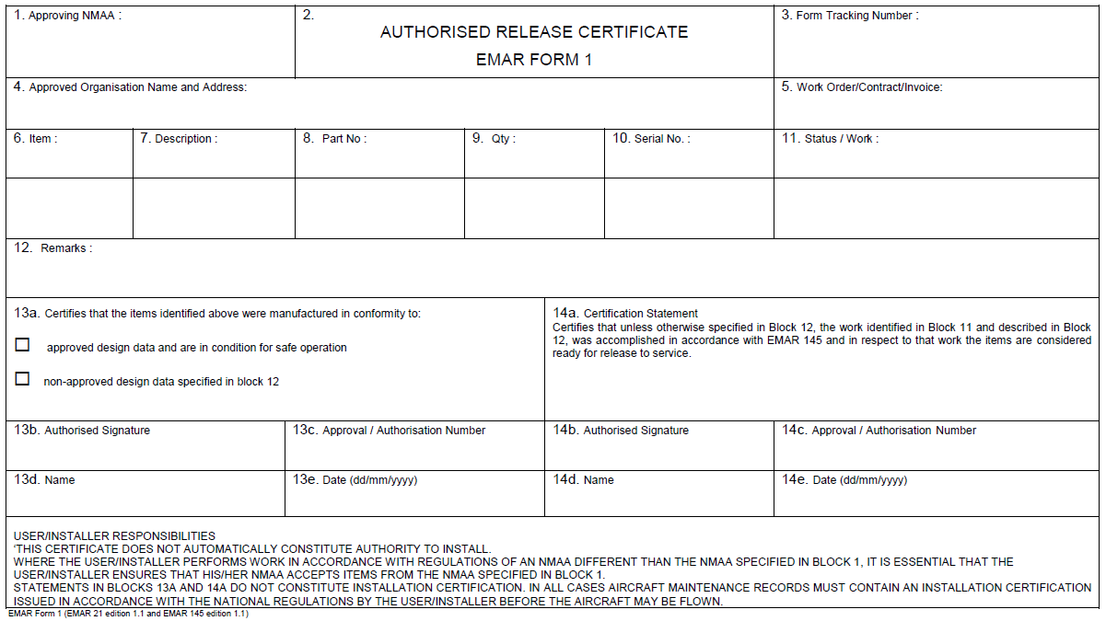
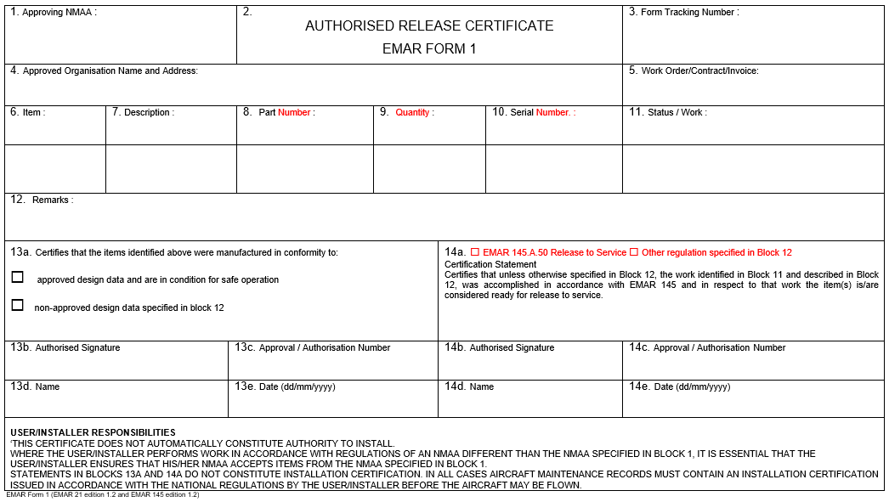

AMC to EMAR Form 1 - Authorised Release Certificate
Use of the EMAR Form 1 for production or maintenance | 2 b) | provide a high degree of assurance that the data has not been modified after signature (if a modification is necessary after issuance, e.g., re-certification of a part, a new form with a new number and reference to the initial issuance should be made); | provide a high degree of assurance that the data is not modified after signature. If a modification is necessary after issuance (e.g., re-certification of a part), a new form is issued with a new number and reference to the initial issuance ►◄; | Paragraph wording amended for improved clarity and readability.
 | 2 c) | To facilitate understanding and acceptance of the EMAR Form 1 released with an electronic signature, the following statement should be in Block 14b: ‘Electronic Signature on File’. | To facilitate understanding and acceptance of the EMAR Form 1 released with an electronic signature, the following statement should be in Block 13b or 14b: ‘Electronic Signature on File’. | ‘13b’ added because this was missing from original AMC which was drawn from EMAR 145/EMAR M.
 |  | When printing the electronic form, the EMAR Form 1 should meet the general format as specified in Appendix I to EMAR 21/145. A watermark-type ‘PRINTED FROM ELECTRONIC FILE’ should be printed on the document. | When printing the electronic form, the EMAR Form 1 should meet the general format as specified in paragraph 2 of the EMAR Form 1. A watermark-type ‘PRINTED FROM ELECTRONIC FILE’ should be printed on the document. | Correct reference inserted.
 | 2 d) | For that purpose, the exchange needs to include: | For that purpose, the exchange should include: | ‘needs to’ replaced by ‘should’ for correct use of nomenclature in the AMCs.
 |  | Trading partners wishing to exchange EMAR Form 1 electronically should do so in accordance with this Acceptable Means of Compliance. It is recommended that they use an established, common, industry method such as Air Transport Association (ATA) Spec 2000 Chapter 16. | Trading partners wishing to exchange EMAR Form 1 electronically should do so in accordance with this Acceptable Means of Compliance. It is recommended that they use an established, common, industry method such as Air Transport Association (ATA) Specification 2000 Chapter 16. | Specification spelled out in full for clarity.
GM to EMAR Form 1 - Authorised Release Certificate
Use of the EMAR Form 1 Block 12 ‘Remarks’ for maintenance |  | Maintenance documentation used, including the revision status, for all work performed and not limited to the entry made in Block 11. A statement such as ‘in accordance with the Component Maintenance Manual (CMM)’ is not acceptable. | Maintenance documentation used, including the revision status, for all work performed and not limited to the entry made in Block 11. A statement such as ‘in accordance with the Component Maintenance Manual ►◄’ is not acceptable. | ‘(CMM)’ deleted because it is not used elsewhere in the document.
 |  | Compliance with Airworthiness Directives or Service Bulletins. | Compliance with Airworthiness Directives or Service Bulletins (or national equivalent). | ‘(or national equivalent)’ inserted for pMS that use an alternative to SBs.
 |  |  | - etc | ‘- etc’ added because this is not an exhaustive list of examples.

EMAR Form 2 – Application for EMAR 145 and/or EMAR M Subpart G Approval |  |  |  | Title changed to reflect that the EMAR Form 2 can also be used for applying for EMAR M Subpart G approval.
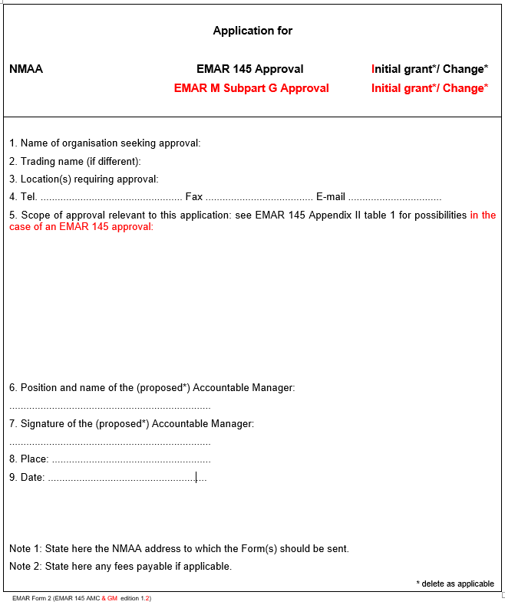
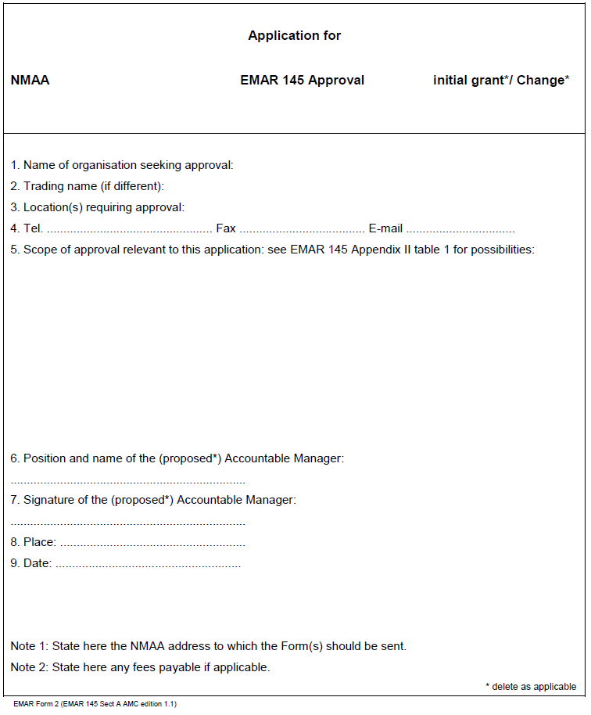

AMC to EMAR Form 2 - Application for EMAR 145 and/or EMAR M Subpart G Approval | 1. |  | For organisations applying for EMAR M.A. Subpart G approval, the full scope of the requested approval must be detailed in Field 5. This information should include: | Additional AMC added to assist organisations applying for M.A. subpart G approval to complete the Form 2.
 | a. |  | Aircraft type/series/group: Each specific aircraft type/series/group for which the organization is seeking approval should be identified. (Type means a specific type or model such as C 130 H type or C 130 J type, Tiger HAP type or Tiger HAD type etc. Series means a specific type series such as Tiger series or Tornado series or Rafale series or Super Puma series or AB 212 series or Gripen series or C 101 series or C 235 series etc. Any number of series or types may be quoted. Group means for example: “Fokker twin turbo prop aircraft”.) | Information taken from EMAR 145 Appendix II
 | b. |  | Airworthiness review: For each specific aircraft type/series/group, it should be indicated whether the CAMO is applying for the EMAR M.A.711(b) privilege to issue recommendations and MARCs after an airworthiness review as specified in EMAR M.A.710.
 | c. |  | AMP to be developed and controlled by CAMO: For each specific aircraft type/series/group, it should be indicated whether the CAMO is applying for the EMAR M.A.711(d) privilege to develop and control the EMAR M.A.302 AMP. (For pMS that do not require a CAMO to develop and control the AMP, this information is not required).
 | d. |  | For each specific aircraft type/series/group, all the EMAR M.A.711(a)3 organisations that will provide support to the CAMO in carrying out any continuing airworthiness management tasks should be listed. (In the case of EMAR M.A.711(a)3(ii) organisations, their CAMO approval number should also be stated.)

EMAR Form 3 – Maintenance Organisation Approval Certificate
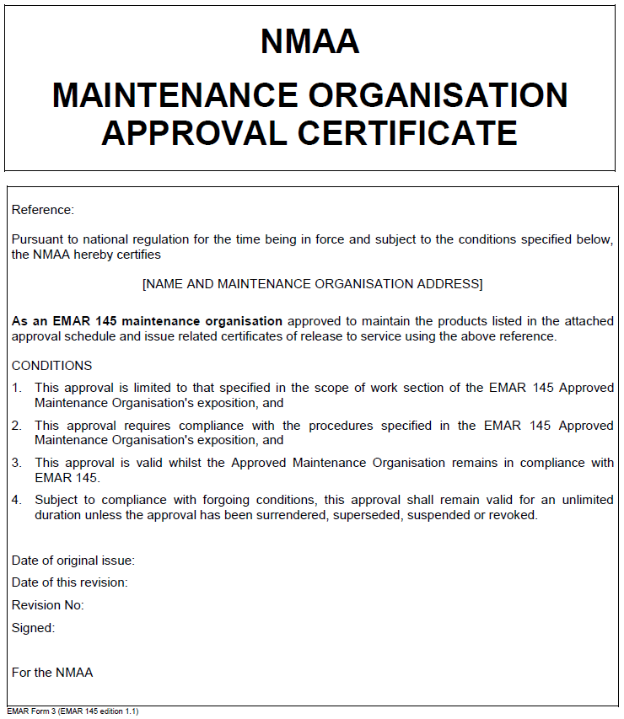
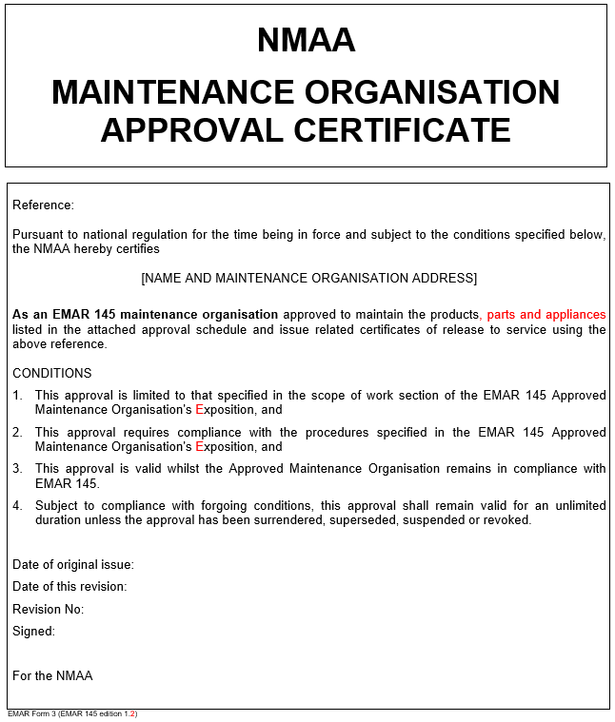
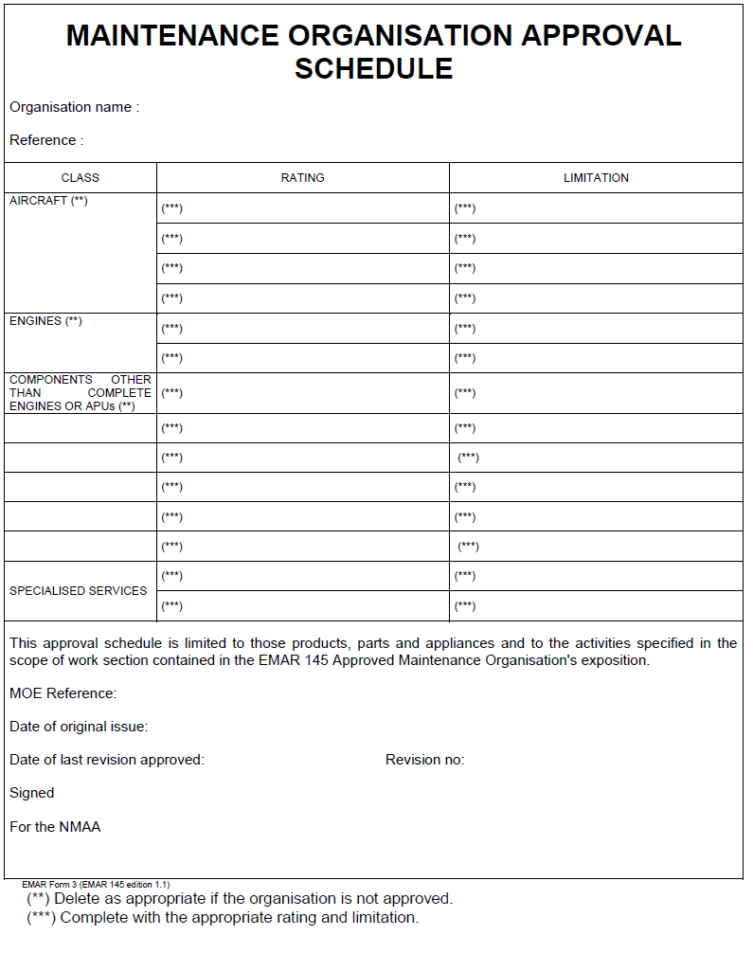
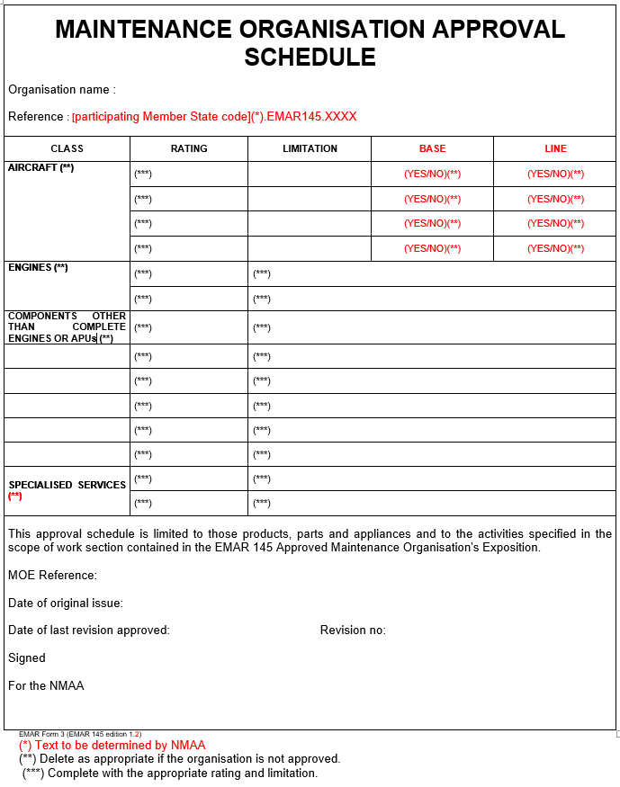

EMAR Form 6 – EMAR 145 Approval Recommendation Report

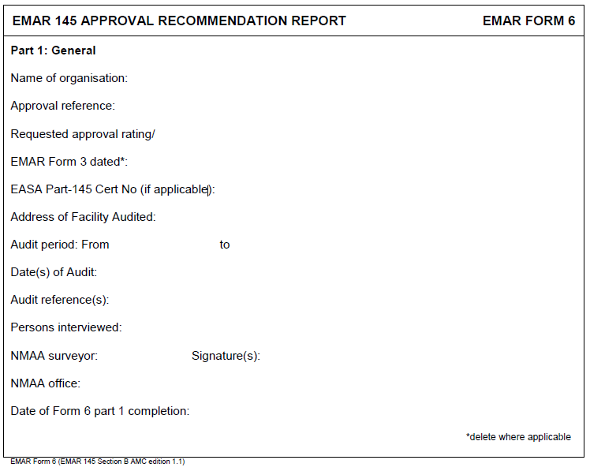
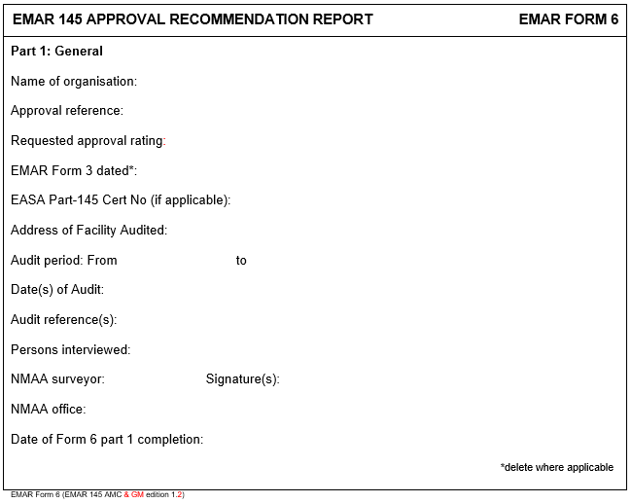
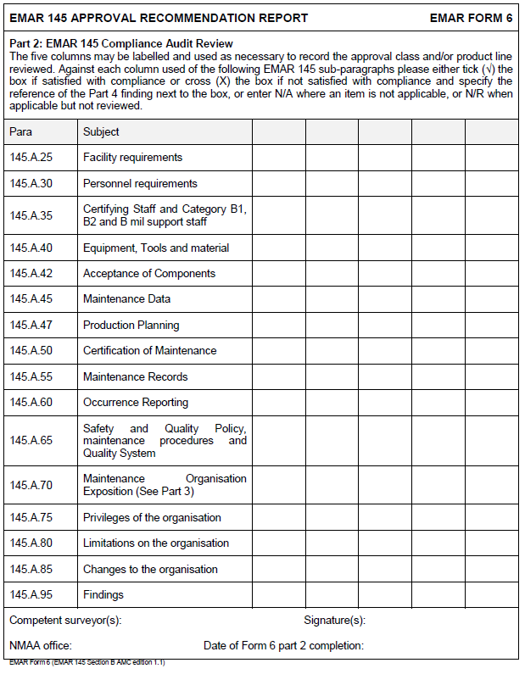
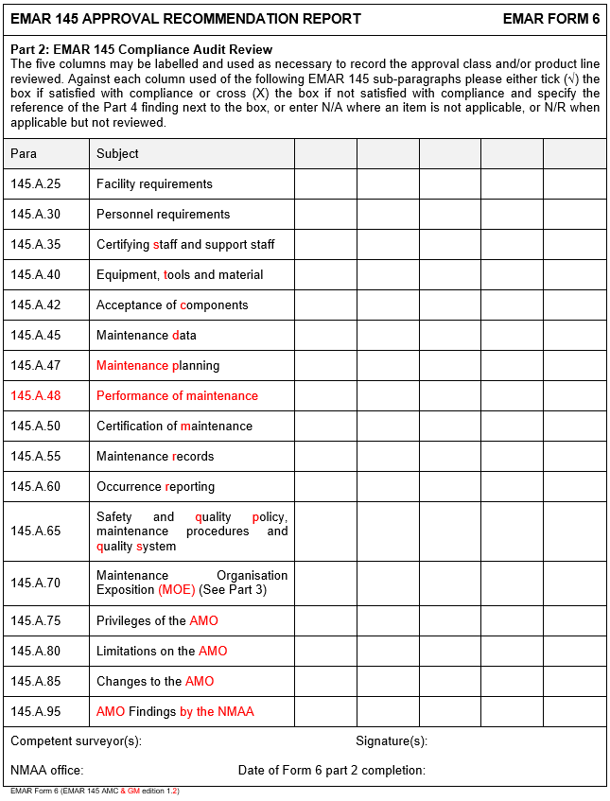
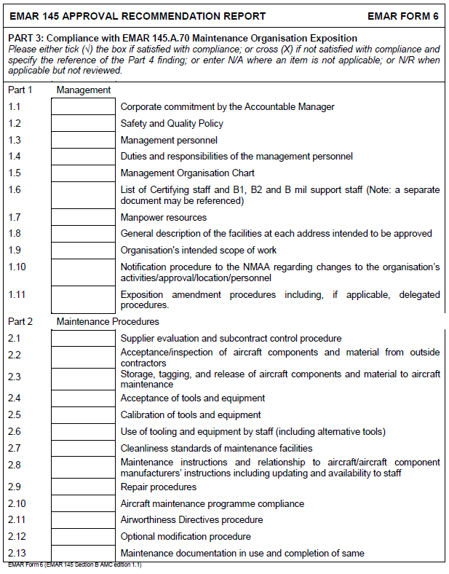
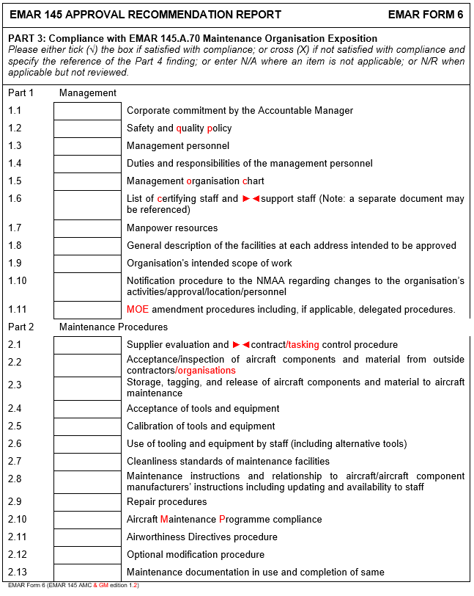
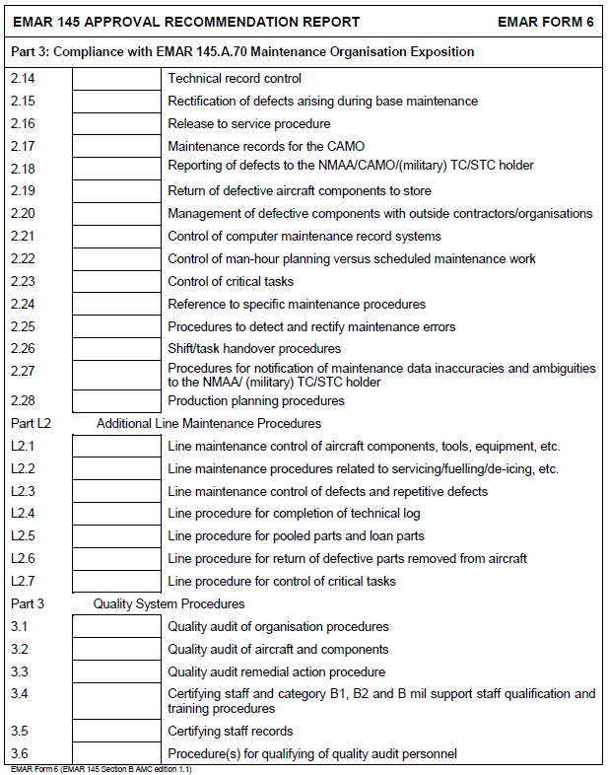
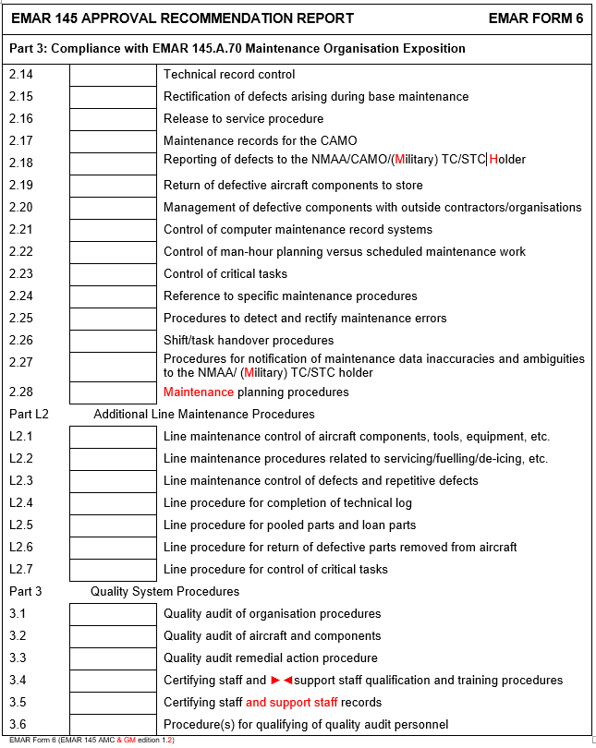
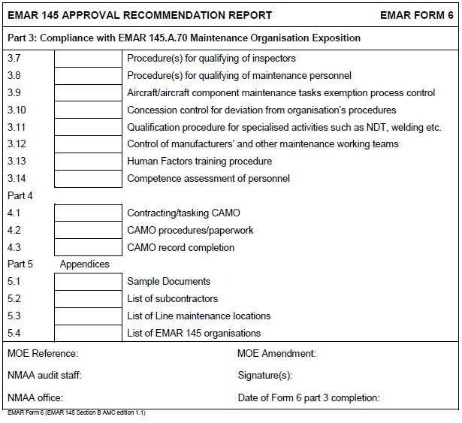
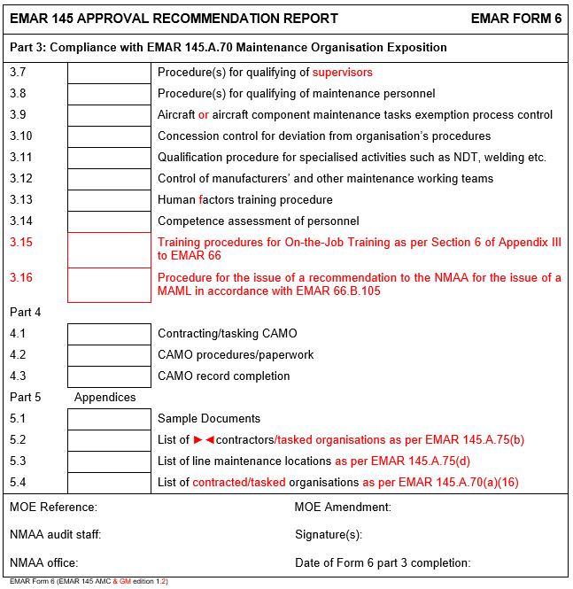
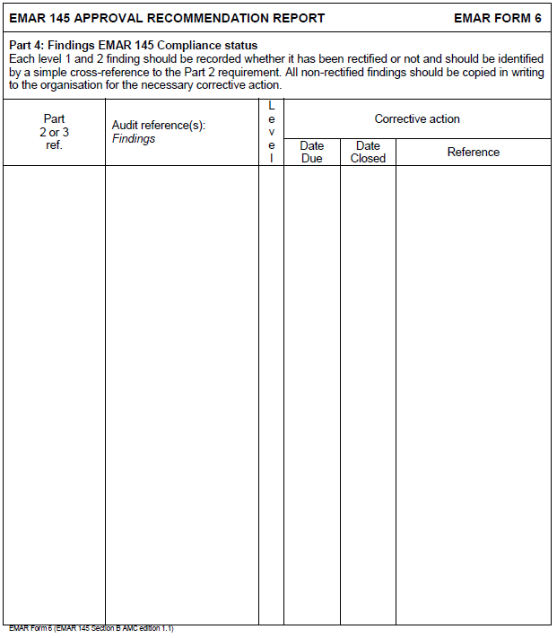
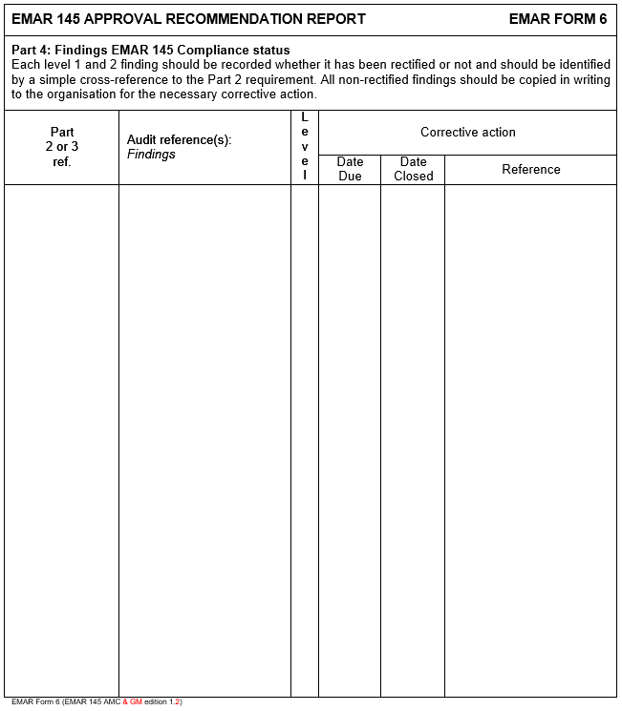
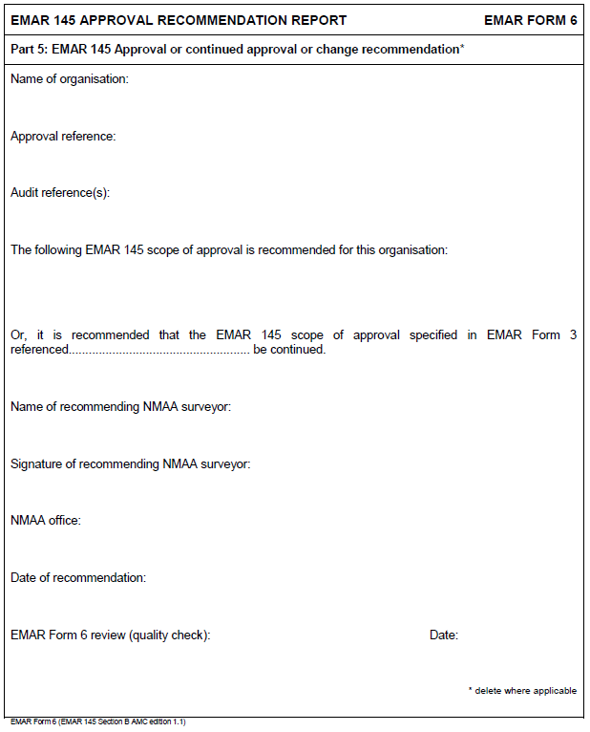
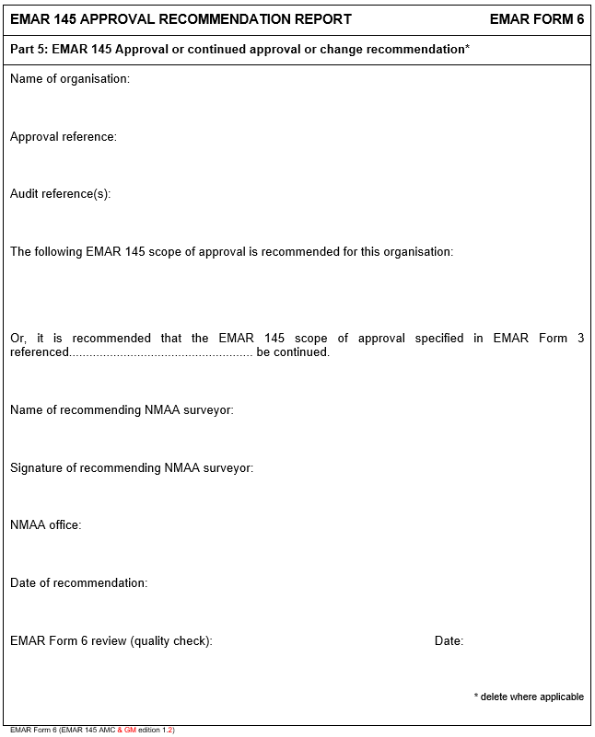

EMAR Form 21 – Application for a Military Permit to Fly |  |  |  | This is a new EMAR form


